VLSI Design and Implementation of Two-Dimensional FIR filter architectures using CSD.
Industry oriented major project report submitted in partial fulfillment of the requirements
for the degree of
Bachelor of Technology
in
Electronics and Communication Engineering
Submitted by

A. Pavan Kumar (19B81A0430)
D. Jahnavi (19B81A0414)
M. Surya Vardhan (19B81A0449)



DEPARTMENT OF ELECTRONICS & COMMUNICATION ENGINEERING
CVR COLLEGE OF ENGINEERING
(An Autonomous Institution & Affiliated to JNTUH)
Ibrahimpatnam (M), Ranga Reddy (D), Telangana
2022-23
VLSI Design and Implementation of Two-Dimensional FIR filter architectures using CSD.
Industry oriented major project report submitted in partial fulfillment of the requirements
for the degree of
Bachelor of Technology
in
Electronics and Communication Engineering
Submitted by
A. Pavan Kumar (19B81A0430)
D. Jahnavi (19B81A0414)
M. Surya Vardhan (19B81A0449)
Under the Supervision of
Dr. Venkata Krishna Odugu
Associate Professor


DEPARTMENT OF ELECTRONICS & COMMUNICATION ENGINEERING
CVR COLLEGE OF ENGINEERING
(An Autonomous Institution & Affiliated to JNTUH)
Ibrahimpatnam (M), Ranga Reddy (D), Telangana
2022-23


Certificate
This is to certify that the mini project titled VLSI Design and Implementation of Two-Dimensional FIR filter architectures using CSD submitted to the CVR College of Engineering, affiliated to JNTUH, by A. Pavan Kumar, D. Jahnavi, M. Surya Vardhan is a bonafide record of the work done by the students towards partial fulfillment of requirements for the award of the degree of Bachelor of Technology in
Supervisor  Signature:  Dr. Venkata Krishna Odugu  Associate Professor  Dept. of ECE  Place:  Date: | Head of the Department  Signature:  Dr. K. Lalithendra  Head of Department  Dept. of ECE
Electronics & Communication Engineering.

Acknowledgement

The satisfaction that accompanies the successful completion of any task would be incomplete without the mention of the people who made it possible and whose encouragement and guidance has been a source of inspiration throughout the course of the project.
It is great pleasure to convey our profound sense of gratitude to our principal Dr. K. Ramamohan Reddy, Dr. K. Lalithendra, Head of the ECE Department, CVR college of Engineering for having been kind enough for arranging the necessary facilities for executing the project in the college.
We would like to express our sincere gratitude to our supervisor, Dr. Venkata Krishna Odugu, Associate Professor, ECE Dept, CVR College of Engineering, whose guidance and valuable suggestions have been indispensable to bring about the successful completion of our project.
We wish to acknowledge special thanks to the Project Coordinator Dr. V. Rama Devi, Associate Professor, of ECE Dept. for assessing seminars, inspiration, moral support and giving us valuable suggestions in our project.
We would also like to express our gratitude to all the staff members and lab faculty, department of Electronics and Communication Engineering, CVR College of Engineering for the constant help and support.
We wish a deep sense of gratitude and heartfelt thanks to management for providing excellent lab facilities and tools. Finally, we thank all those whose guidance helped us in this regard.

Abstract

The two-dimensional (2D) Finite Impulse Response (FIR) filter architectures are required for the processing of two-dimensional signal processing applications such as image filtering, image restoration, image sharpening, etc. The power-area-delay efficient hardware architectures are preferable for these filtering applications. Hence, in this proposed work, an efficient 2D FIR filter is designed using multiplierless design techniques using Canonical Signed Digit (CSD). In the 2D FIR, the symmetry in the coefficients matrix will reduce the number of multipliers. Due to this symmetry concept, the complexity and power is reduced for the filter architecture. The remaining multipliers the filter architectures may be optimized by the CSD number representation to achieve mutiplierless design. In this concept, the multiplication process is done by the adders and shifters only.
This proposed architecture will be coded in Verilog HDL and validation may be carried out in CADENCE environment using NC Simulator and synthesis tools. The area, power and delay reports are generated and will be compared with existing 2D FIR filter hardware structures. The filter coefficients for circularly symmetry design will be generated using MATLAB. The fully direct-form structure will be considered for the design of proposed 2D FIR filter architecture.

Table of Contents
Acknowledgement i
Abstract ii
Contents iii
List of figures v
List of Tables vi
Chapter 1 Overview 1
1.0 Introduction 1
1.1 2-D FIR and 2-D IIR Filters 1
1.2 Performance Metrics 4
A Area 5
B Power Dissipation 5
C Delay 6
D Power-Delay Product (PDP) 7
E Area-Delay Product (ADP) 7
1.3 ASIC Design Flow 8
1.4 Objectives

Chapter 2 Literature Survey 11
2.1 Introduction 11

Chapter 3 Design of FIR filter 13
3.1 Introduction 13
3.2 Design of FIR filter using CSD 13

Chapter 4 Implementation of FIR filter architecture 21
4.1 Multiplier less FIR filter architecture implementation
using CSD 22
Chapter 5 Performance Analysis and Results 27
5.1 Introduction 27
5.2 Sample outputs 28

Conclusion 35
References 36

List of Figures

1.2.1: The general architecture of the 2-D IIR filter for filter length N = 4 3
1.2.2: The general architecture of the 2-D FIR filter for filter length N = 4 4
1.3: ASIC design process steps 8
3.2.1: Contour of Low Pass Filter using McClellan transform 13
3.2.2: Frequency response of Low Pass Filter using McClellan transform 14
3.2.3: Architecture of FIR filter in the direct form using CSD coefficients 15
for row-filter 1
3.2.4 Architecture of FIR filter for row-filter 2 15
3.2.5 Architecture of FIR filter for row-filter 3 16
3.2.6 Architecture of FIR filter for row-filter 4 17
3.2.7 Architecture of FIR filter for row-filter 5 17
3.2.8 Architecture of FIR filter for row-filter 6 18
4.1: General Architectures of 2D FIR filters Fully Direct form 19
4.2: Fully direct form 2D FIR Filter architecture for continuous coefficients with symmetry 20
4.2.1: The architecture of 2D FIR filter in the fully direct form using CSD coefficients 21
4.2.2: Architecture of FIR filter using shift register blocks. 21
4.1.3: RTL Schematic of row filter 1 22
4.1.4: RTL Schematic of row filter 2 22
4.1.5: RTL Schematic of row filter 3 22
4.1.6: RTL Schematic of row filter 4 25
4.1.7: RTL Schematic of row filter 5 25
4.1.8: RTL Schematic of row filter 6 25
4.1.9: RTL Schematic of 2D FIR filter 26

List of Tables

1.1: Comparison between FIR and IIR digital filters 3

Chapter One
Overview
1.0 Introduction
The Two-Dimensional (2-D) digital filter is that the information propagates in two independent directions, and it is used to process the two-dimensional signals. The 2-D digital filters are used for various theoretical and practical real-time applications. In image processing applications, for example, to enhance the low-quality X-ray photograph-based images and to compensate for the linear optical degradations, 2-D digital filters are used. The 2-D digital filters are found used in the pre-processing data in 2-D pattern recognition systems, pre-filtering in picture encoding, processing of data derived from multidimensional arrays of geographical exploration, earthquake/nuclear test detection, Radar, Sonar, etc. [1].
The 2-D digital filters are also used for image enhancement, image restoration, face recognition, biometric systems, enhancement of satellite weather photos & communication [2-4], enhancement of television pictures, beamforming [5], seismic data processing, video processing, and computer vision applications.

1.2 2-D FIR and 2-D IIR Filters
The 2-D digital filters are two types as Finite Impulse Response (FIR) and Infinite Impulse Response (IIR) filters. The 2-D FIR filters are also called non-recursive filters, the output depends on the present and previous inputs, and there is no feedback connection. The FIR filters have a finite duration and are always stable. These filters are in a linear phase, and the structure is modular and regular to design easily. The 2-D IIR filters are also called recursive filters, consisting of feedback between output and input. The output is determined by both inputs and previous outputs, and it may be unstable with an infinite duration. The IIR filter gives a sharp frequency response with high computational efficiency and less hardware. The comparison of basic FIR and IIR digital filter features is presented in Table 1.1.
In the design of the filter, the optimized filter coefficients are generated, and it produces a magnitude response, it is approximated version of ideal specifications with some tolerance. The design of 2-D filters is not as simple as One-Dimensional (1-D) digital filters. The multidimensional range exponentially increases the filter coefficients. The increased quantity of filter coefficients increases the number of processing blocks such as adders, multipliers, and memory elements. So, the implementation of architectures for 2-D digital filters is also complicated compared to the implementation of 1-D filter architectures.
For the high data rate image processing applications, the 2-D digital filters need to be simulated using the general-purpose computer. For this simulation, dedicated hardware architectures are required to attain high throughput and meet the specifications. The dedicated architectures can be implemented using Very Large-Scale Integration (VLSI)-Application Specific Integrated Circuit (ASIC) based, and Field Programmable Gate Array (FPGA) based approaches. Here, ASIC design is a semi-custom design style based on a standard-cell library. The FPGA design style is reprogrammable design, which can be used for prototyping purposes. In this work, the ASIC design approach is used to implement the filter architectures.

Table 1.1: Comparison between FIR and IIR digital filters
S. No | Comparison Parameter | FIR Filter | IIR Filter
1 | Type | Non-Recursive type | Recursive type
2 | Feedback | Does not Exist | Exist
3 | Output | Depends on present and past inputs | Depends on present & past inputs, and past output
4 | Stability | High | Less
5 | Transfer function | Consists of Zeros only | Consists of Poles and Zeros
6 | Implementation | Easy | Difficult
7 | Computational Efficiency | Less | More
8 | Delay | High | Low
9 | Controllability | More | Less
10 | Memory | More | Less

The general architectures of 2-D IIR and FIR filters and corresponding transfer function equations are presented in this section. The general transfer function or relation between the output and input of the 2-D IIR filter is expressed by equation (1.1),

$H\left(z_{1},{ z}_{2}\right)=\frac{Y(z_{1},{ z}_{2})}{X(z_{1},{ z}_{2})}=\frac{\sum_{i=0}^{N1}{\sum_{j=0}^{N2}{a_{ij} z_{1}^{-i}z_{2}^{-j}}}}{1-\sum_{i=0}^{N1}{\sum_{j=0}^{N2}{b_{ij}}{ z}_{1}^{-i}z_{2}^{-j}}}$ 1.1
where, $X(z_{1},{ z}_{2})$ represents the input, and $Y(z_{1},{ z}_{2})$ is the output of the 2-D IIR digital filter with size of ${ N}_{1}×N_{2}$ , $a_{ij}$ and $b_{ij}$ are the numerator and denominator coefficients, respectively.
The basic 2-D IIR filter architecture based on the above transfer function expression is shown in Figure 1.1. In this structure, the memory elements viz., $z_{1}^{-1}$ represents the shift register with the size of M, where M is the length of the row of an input image with size of $M×M$, and $z_{2}^{-1}$ represents the single memory element. It also consists of multipliers and adders to produce the final filter output.
Figure 1.2.1 The general architecture of the 2-D IIR filter for filter length N = 4.
The general formulation of the 2-D FIR filter transfer function is given by equation (1.2) and the general architecture of 2-D FIR filter is shown in Figure 1.2.
$H\left(z_{1}, z_{2}\right)=\frac{X\left(z_{1}, z_{2}\right)}{Y\left(z_{1}, z_{2}\right)}=\sum_{i=0}^{N1}{\sum_{j=0}^{N2}{h(i,j)z_{1}^{-i}z_{2}^{-j}}}$ 1.2

where,$h\left(i,j\right)$ impulse response matrix of 2-D FIR filter with an order of${ N}_{1}×N_{2}$, and $X(z_{1},{ z}_{2})$ and $Y(z_{1},{ z}_{2})$ are input and outputs of filter respectively. In the 2-D FIR filter architecture also, $z_{1}^{-1}$ is the shift register with the size of M, and $z_{2}^{-1}$ is a single memory element.
Figure 1.2.2 The general architecture of the 2-D FIR filter for filter length N = 4.
The performance metrics related to the VLSI implementation of architectures are described in section 1.2. The design flow of ASIC- based tools are described in section 1.3. The merits and demerits of the 2-D FIR filter architecture implementation techniques available in the current literature, which have motivated to work are explained in section 1.4. The objectives of this research work are mentioned in section 1.5. Finally, the thesis organization is presented in section 1.6.

  - Performance Metrics
The VLSI-based implementation of architectures is appraised by objective functions such as VLSI design metrics area, power consumption, delay, Area-Delay Product (ADP), and Power Delay Product (PDP).
The great reduction in the feature size (minimum transistor size) of VLSI devices is the main cause of the incremental growth of the VLSI technology. The feature size of the transistor is reduced from 5µm to 2µm, 2µm to 1µm, and next 1µm -0.5µm, 0.35 to 0.18µm, 0.18µm to 90nm, and about 90nm to 45nm in the 20th century [6]. In industry, further reduction is taken place also. This great reduction in the feature size of the transistor affects the VLSI technology in terms of various ways. First, the density of the chip is affected, and more than 100 million transistors are placed in the VLSI chip today. Hence very high demand is there for the optimization to reduce the area of the dedicated architecture for present technology.
Second, the devices need to operate for high frequency, and the delay of the gates and interconnection delay is very much significant. The delay reduction for intrinsic gates, local and global interconnection delays have to be decreased for the improvement of the performance of any architecture. Third, the advancement in the feature size causes scaling of the threshold voltage and power supply. Further, due to this scaling the leakage power of the transistors is increased. Power analysis is very important in VLSI design and implementation. However, the trade-off between area, delay, and power is a challenging task for VLSI-based designs. The appropriate optimization techniques to reduce area, delay, and power consumption are needed to satisfy the specifications of applications and products.

- Area
The VLSI design of any architecture implementation consists of a few steps viz., high-level design, logical design, and physical layout. The architecture design is composed of functional blocks, functional blocks are constructed by arithmetic blocks like multipliers, adders, and memory elements, etc. These blocks are further constructed using gates and transistors. The area of the VLSI design chip is defined by the number of gates/transistors involved in the architecture based on the synthesis. Otherwise, the occupancy of all the cells or gates for architecture in the physical layout is treated as the area of the chip. The product of length and width of the physical layout produced by the physical design using Electronic Design Automation (EDA) tools is treated as an area of the architecture with units of µm².

- Power Dissipation
Power consumption is the main VLSI design issue and management of power is required for digital circuit design. The design and implementation of low power architectures affect the performance, area, and power dissipation [7]. The optimization of power consumption can be done from the device level to the architecture level. The total power consumption of Complementary Metal Oxide Semiconductor (CMOS) circuits is mainly sourced by standby power and dynamic power is given by equation (1.3).
$P_{T}=P_{Short ckt}+P_{Leakage}+P_{Dynamic}$ 1.3

$P_{Short ckt}$ is short circuit power occurred due to the low impedance path between power rails ($V_{DD} \& V_{SS}$) during the switching mode or standby mode. Next, the $P_{Leakage}$ is the leakage power also called static power. The unwanted current passing between junctions and rails at steady state is termed as leakage current $I_{Leakage},$the leakage power is given by equation (1.4).
$P_{Leakage}=I_{Leakage}{.V}_{DD}$ 1.4

$P_{Dynamic}$ is dynamic power defined as follows: The energy to charge the Load capacitor ($C_{L}$) to the power supply $V_{DD}$ is approximately given as in equation (1.5).

$E=C_{L}.V_{DD}^{2}$ 1.5
If the circuit is functioning at the clock frequency of $f$, then the dynamic power consumption is given by equation (1.6).

$P_{Dynamic}=f.C_{L}.V_{DD}^{2}$ 1.6

But the $C_{L}$ is always not switching, then the percentage of capacitor switching considered as activity factor and it is denoted by α. The dynamic power can be written as equation (1.7).

$P_{Dynamic}=α.f.C_{L}.V_{DD}^{2}$ 1.7

- Delay
The delay is an important parameter to estimate the performance or speed of the VLSI design-based architecture. The propagation delay is defined as the time estimation between the input and output [8]. The high-speed digital architecture needs the small delay introduced by logic gates used in the system or architecture when the inputs change. Fall time delay is denoted by t_{f,} produced by when the output changes from ‘1’ to ‘0’, and the rise time delay is denoted t_{r}, introduced by the output change from ‘0’ to ‘1’. The rise time and fall times can be estimated by analyzing the electronic transitions of the circuit elements parasitic resistance and parasitic capacitance.
The propagation delay t_{p} is defined as time delay that occurred from input to output, and it is given by equation (1.8)

$t_{p}=\frac{t_{pf}+t_{pr}}{2}$ 1.8
where, $t_{pf}$ is propagation fall time of output change from $V_{DD}$ to $V_{DD}/2$, and $t_{pr}$ is the propagation rise time of transition from ‘0’ to $V_{DD}/2.$
In the proposed work, the longest critical path delay is considered as the total delay of the architecture. It consists of propagation delay related to the gates involved in the path and connecting wires delay also. In this work, two other performance metrics, viz., PDP and ADP, are also used to measure the performance of the VLSI implementation-based architecture of proposed 2-D FIR filters. The ADP and PDP are the simple product of area and delay values and product of power and delay values, respectively.

- Power-Delay Product (PDP)
The Power consumption of a logic gate and propagation delay are related, and it can be used as a parameter to measure the figure of merit. The delay is determined by the speed at which the given amount of power or energy can be stored by the gate capacitors. The (high power dissipation) faster the energy transfer the faster the gate. In the given technology and gate topology, the product of propagation delay and power consumption is constant. The ideal gate should always be faster and consumes less power; hence PDP is used as a metric. The simple formula for the PDP is given by equation (1.9).
$Power-Delay-Product \left(PDP\right)= Power\left(mW\right)×Delay(ms or ns)$ 1.9
- Area-Delay Product (ADP)
Similarly, the area of the gate and delay are multiplied to observe the impact of area and delay of the structure, which is defined as Area-Delay-Product (ADP). The lower ADP is always better. A trade-off should be maintained between the propagation delay and silicon area in the VLSI design. The area of the transistor may be increased sometimes to improve the delay, but it is caused to increase the silicon area. The less hardware architecture may consist of the longest critical path, which is not preferable. So, ADP can be used as a metric, as given by equation (1.10).

$ADP= Area\left({µm}^{2}\right)×Delay(ms or ns)$ 1.10

  - ASIC Design Flow
In this work, the proposed 2-D FIR filter architectures are implemented by adopting the digital ASIC design. The ASIC design flow is a silicon-proven Integrated Circuit (IC) design process, and it is mature. This design includes design- conceptualization, design verification, design validation, physical implementation, chip optimization. The flow diagram gives an overview of ASIC design, as shown in Figure 1.3.
Figure 1.3: ASIC design process steps.

The first step of the ASIC design process is specifications, in which the features of architecture and specifications viz., area, delay, power, and time are defined. Based on the specifications, the Register Transfer Level (RTL) code needs to be generated using Hardware Description Language (HDL). A proper test bench also needs to be developed in HDL to verify the RTL code.
Once the design entry is completed, the RTL codes are functionally and logically verified by simulation. The correctness of the RTL code, timing verification, and meeting the requirements will be focused on this level.
Next, the RTL code is converted into a gate-level netlist based on the standard cell library using synthesis tools to meet the given specifications in terms of area, delay, power, and time. If the logic synthesis meets the timing constraints, then the design can be proceeded for testing by Design for Test (DFT). The memory testing, checking the faults, and scan path insertion are included in the DFT level.
After that, the entire design is portioned into multiple modules or blocks by keeping in mind to meet the specifications and performance, feasibility, availability of resources, utilization of resources, and allocation. In the floor planning step, planning to place the blocks in the chip, optimized power distribution lines, pin placement automatically done by tools. Here, the designer aims to minimize the chip area, signal delay, and the design must be easily routable.
The standard cells of entre architecture are placed in a row at the placement level. Good placement improves the performance, reduces the power dissipation, reduces the net lengths and the timing of the entire architecture.
Clock Tree Synthesis (CTS) is one of the essential step. It provides the proper clock tree for the connection of sequential elements and meets the given specifications in terms of time, area, power, and speed. Various optimized CTS approaches are available in the tools to optimize the design.
Next, the routing is taken place between all the blocks and cells. Each net delay is estimated here, and the total optimized wire delay is calculated for the entire chip layout. After routing, the design is verified by physical verification tools such as Design Rule checker (DRC) and Layout Versus Schematic (LVS).
Finally, the Graphical Data Stream Information Interchange (GDSII) is generated for the tape-out of the chip. The proposed 2-D FIR filter architectures are implemented up to the place & route and physical layout generation in this work. The ASIC design is carried out by Cadence tools such as Incisive Enterprise Simulator (ISE) for simulation, RTL compiler and upgraded version Genus tools for synthesis and Innovus tools to place & route in physical design.
  - Objectives
The main objective of this research work is to implement efficient VLSI architectures for 2-D FIR filters and comparing with various existing 2-D digital filter architectures. The objectives of this work are as follows:
- To study the existing 2-D digital filters design techniques and implementation of architecture approaches with advantages and disadvantages in the current literature and compare their performance in terms of various metrics.
- To implement low power and memory-efficient block-based 2-D FIR filter architecture using high-speed multipliers and high-speed adders to reduce the area, delay, and power consumption.
- To design and implement low complexity circularly symmetry 2-D FIR filter and implementation of architecture using CSD format to replace the conventional multipliers.
1.5 Organization of the report
The applications of the 2-D FIR filters, basic architectures of the 2-D FIR and IIR filters, and performance metrics used for the evaluation of VLSI architectures of filters and the classification of 2-D digital filters and corresponding design techniques and various implementation of architecture approaches are discussed in this chapter.
The detailed survey on design and implementation methods of FIR filter architectures available in the in chapter 2.
The symmetry in the filter coefficients decreases the number of multipliers in the FIR filter architectures. By keeping the advantages of the symmetry, a low complexity circular symmetry 2-D FIR filter architecture is designed and implemented using CSD representation of coefficients presented in chapter 3.
The implementation of VLSI design to obtain the improvement in the power, area, and delay of the 2-D FIR filter architecture. This proposed work is explained in detail in chapter 4.
Finally, performance analysis and obtained results are discussed in chapter 5 followed by conclusion and references.

Chapter Two
Literature Survey

  - Introduction
Many optimization algorithms are proposed for designing the 2D FIR filters, such as Genetic Algorithm, Particle Swarm and Differential Evolution, ABC algorithm, etc. (Chandra and Chattopadhyay 2016). The above methods suffer from the large execution time and premature convergence. The optimization is carried out to meet the filter frequency domain specifications, passband ripple, and stopband ripple. The McClellan transformation method is the best technique for the design of 2D FIR filters for an efficient hardware structure implementation.
McClellan transformation-based method results in a low complexity 2D FIR architecture using a transformation approach. The circularly symmetric, fan type and elliptic filters are designed by kth-McClellan transformation technique with remarkable results. The transformation approach is most valuable for linear phase filters and they should be in the symmetry of quadrant. This algorithm is fast and it gives a moderate degree and good implementation. Here, the one-dimensional (1-D) FIR filter is designed and mapped to 2D FIR Filter using McClellan transform (Das et al. 2019). The kth-McClellan transform is added by a new term which is used to get circular shape at all frequencies is called as T1 transformation. The T1 transformation is modified into to approximate the constants to avoid the squarish shape at the center of the low pass filter is T2 transformation.
  - Design Techniques of 2-D FIR and IIR Filters
The digital filters are designed to meet the given specifications of the filter for appropriate applications. For all signal and image processing applications, the phase linearity, good magnitude response in the passband, high sampling frequency, fewer stopband ripples, and the low complexity parameters related to architecture implementation, such as area, power, and delay, are often required. Basically, the 2-D FIR filters can be designed using transformation-based and direct methods.
The transformation methods can be applied to fixed filters and variable filters. Variable digital filters mean the spectral characteristics of the filter are varied in real-time without redesigning the filter by introducing slight complexity. The variable digital filters are designed either by Farrow structure plus Park-McClellan transformation or direct variable magnitude response methods. Fixed filters are designed using generalized McClellan transformations, T1 and T2 transformations including additional terms, and modified McClellan transformations P1 and H1 transformation methods. The direct techniques for variable digital filters are designed using the Fourier method and optimization methods, such as 1-D polynomial approximation, least-square minimization, real-complex decomposition, array-array decomposition, and matrix array decomposition techniques.

- McClellan Transformation based
The linear phase is an essential feature of the 2-D digital FIR filters for processing images. These linear phase 2-D filters can be designed by conventional methods, which are very standard methods used to develop 1-D filters viz., windowing technique, multiple exchange-Chebyshev technique, frequency sampling method, and linear programming methods. The windowing method-based design is easy, and it is used to design the filters with any order and with any phase and magnitude characteristics. The other three design approaches produce better linear phase filters, which are nearer to the ideal response, but more design time. The McClellan transformation technique overcomes this problem in linear phase 2-D filters design. The McClellan transformation technique can be used to design higher-order filters and the time required for the design is modest. The McClellan transformation approach is a transformation method of zero-phase 1-D FIR filter to zero-phase 2-D FIR filter using a substitution of extra variables. This method is mainly applied to the odd length 1-D FIR filters.
Mersereau et al. [1] explained the generalized McClellan transformation techniques and utilization for designing linear phase 2-D FIR filters with quadrilateral symmetry. In this work, two basic algorithms are suggested to estimate the transformation parameters. First, the constrained approximation approach, which is preferred for the first order transformations or simultaneous contour matching of various filters. The second algorithm designs a higher-order filter with a piecewise constant transfer function. The efficiency of these algorithms is observed by applying on few examples and proving that the designed time is less. This transformation technique is best suitable for the design of linear phase 2-D FIR filters.
Bindima and Elizabeth [9] described the basic classification of 2-D FIR filter design, and the main features of various design techniques are explained in the survey. The authors also addressed the difference between variable filters and fixed filters based on transformation techniques and direct design techniques. In this paper, the variable one dimensional (1-D) FIR filter with tunable cut-off frequencies is designed using a Farrow structure, and it is converted into a 2-D FIR filter with the McClellan transformation method. To reduce the complexity of the filter, the coefficients are optimized using an Artificial Bee Colony (ABC) algorithm, and further, the filter coefficients are represented in CSD number format.
Liu and Tai [13] suggested a modified k^{th} order version of the original McClellan transformation technique. The original McClellan transformation method is suitable for lower-order LPFs and HPFs, which cannot produce circularity for the long radii in higher-order filters. In this paper, two higher-order transformations, such as T1 and T2 transformations, are proposed to design circular symmetry-based wideband 2-D FIR filters by introducing two cascaded terms in the transformation. Here, a single proposed transformation is used to convert the 1-D FIR filter into a 2-D FIR filter without any optimization procedure and computation. The designed 2-D FIR filter needed the same number of multipliers as the 1-D prototype FIR filter.
Bindima et al. [10] proposed a novel k^{th} order McClellan transformation technique to design 2-D FIR filters to attain perfect circularity at the wideband radius. In this work, the squarish effect in the contour at long radii of conventional transformations and existing transformations [13] is overcome by modifying the McClellan transformation as P2 transformation. A cascading term $∅(ω_{1},ω_{2})$ is introduced to the K^{th}-McClellan transformation to eliminate the squarish effect at higher cut-off radii in the 2-D FIR filter. The term $∅\left(ω_{1},ω_{2}\right)$ is determined by linear least square estimation expression as given by equation (2.1).

$∅\left(ω_{1},ω_{2}\right)=0.25{\left(\cos\left(\frac{ω_{1}}{2}\right)+\cos\left(\frac{ω_{2}}{2}\right)\right)}^{2}$2.1

This function satisfies all constraints viz., it behaves as symmetrically along the $ω_{1}$ axis and $ω_{2}$axis, it is normalized for all frequencies of $ω_{1}$and $ω_{2}$ the behavior is not altered at the origin, and it produces the zero value at corners ($π,π), \left(π,-π\right), \left(-π,π\right), \left(-π,-π\right).$
Manuel et al. [11] designed a sharp wideband circular symmetry 2-D FIR filter by utilizing the modified McClellan transformations T1 and T2 [13] and Frequency Response Masking (FRM). The FRM approach is introduced in a 1-D FIR prototype filter to attain sharpness. In the FRM method, the interpolation is produced by delay elements in the filter structure to achieve sharpness. The multiplierless 1-D FIR filter is designed using CSD space to reduce the complexity, and it is transformed into a multiplierless 2-D FIR filter using T1 and T2 McClellan transformations. This 2-D FIR filter design is efficient and very fast compared to conventional design methods.
Yeung and Chan [12] proposed the new structures of tunable fan and elliptical type 2-D FIR filters using Farrow structure and McClellan transformations. The 1-D variable digital filter is designed for desired tunable cut-off frequencies. This design is implemented in the form of a Farrow structure, and sub-filters of the Farrow structure are converted into variable 2-D FIR filters using the McClellan transformation technique. The control parameter of the Farrow structure and transformation parameters are varied to achieve the required inclination fan and orientation of elliptical responses. The fan type 2-D FIR filter is designed by using first-order McClellan transformation with an arbitrary inclination is given by equation (2.2),

$\cos\left(ω\right)=t\left(0, 0\right)+t\left(1, 0\right)\cos\left(ω_{1}\right)+t\left(0, 1\right)cos\left(ω_{2}\right)+t\left(1, 1\right)\cos\left(ω_{1}\right)\cos\left(ω_{2}\right)$ 2.2
where, $t(i,j)$ are transformation coefficients $(i, j ϵ [0 ,1]).$ To reduce the complexity of the filters, the multiplierless architecture is implemented using shift and add operations only. The Sum-of-Powers-of-Two (SOPOT) technique represents the sub-filter coefficients and transformation parameters, which is easily suitable for shift and add operations.
Shyu et al. [14] investigated the McClellan transformation to design 2-D FIR variable filters. In this work, the desired variable characteristics of the 2-D FIR filter are achieved by the perfect design of a variable 1-D prototype FIR filter with a single tuned parameter. The conventional McClellan transformation is extended to design fan-type, circularly symmetric, and elliptically symmetric variable 2-D FIR filters. First, the cut-off orbit function is determined based on the type of symmetry. Next, the variable 1-D prototype filter is designed and transformed into a variable 2-D FIR filter, where both the filters are varied by the same tunable or variable parameter. The efficiency of the proposed designs is illustrated using LPFs with elliptical and circular symmetry.
- Optimization Algorithms and Frequency Sampling-based
In the digital filter design, the main aims are stability computation time, and complexity of computations. The objective of optimized algorithms is the achievement of the purposes of the digital filters. The metaheuristic optimization algorithms are used to solve problems in various fields, and these algorithms are also used for the 2-D digital filter design.
Kockanat and Karaboga [17] presented a survey on metaheuristic algorithms for the optimized design of 2-D digital filters. In this paper, two groups of metaheuristic optimized algorithms are explained, such as evolutionary-based algorithms: Genetic Algorithms (GA), Differential Evolution (DE), and Swarm intelligence-based algorithms: Particle Swarm Optimization (PSO), Harmony Search Algorithm (HSA), Artificial Bee Colony algorithm (ABC), and Immune Algorithms (IA). The basic concepts of non-recursive and recursive 2-D digital filters and related design problems are addressed. The solutions for problems encountered in the 2-D FIR and IIR filters are suggested using appropriate metaheuristic algorithms. The work is concluded that the design problems still have great interest to researchers in the various parts or fields.
Su et al. [20] described a hybrid algorithm based on the Clonal Selection Algorithm (CSA) and Frequency Sampling Method (FSM) for the design of a 2-D FIR filter with the case study of circularly symmetric zero phases LPF. In the FSM, the required frequency response is sampled in the Cartesian grid with equally spaced points, which results in a Discrete Fourier Transform (DFT) and produces a faster filter for given specifications easily. The sampling frequencies of the transition band are optimized in the digital filter, and CSA produces a planar response matrix for the 2-D digital filter. This hybrid technique attained a good performance in the passband and stopband of the frequency response of the 2-D FIR filter.
Dwivedi et al. [18] proposed a modified ABC algorithm to solve the optimization problems in the design of a 2-D FIR filter and reduce the filter's power consumption. The circular symmetric 2-D FIR filter design is formulated, and optimization is carried out by an optimized coefficient search algorithm Modified ABC (MABC) to meet the desired specifications of the 2-D FIR filter. The optimized 2-D FIR filter is designed using a MABC algorithm, and it is implemented on FPGA to validate the efficiency of the filter in real-time. The performance analysis states that the difference between an ideal filter and a practical filter is less in terms of stopband and passband ripples. The proposed work is compared with conventional metaheuristic optimization algorithms and concluded that the dynamic power is significantly less during the execution of the 2-D FIR filter than the state-of-the art work.
Aggarwal et al. [19] proposed a new method for the design of quadrantally symmetric 2-D FIR filter using Fractional Derivative Constraints (FDC) and Hybrid Particle Swarm Optimization-Gravitational Search Algorithm (HPSO-GSA) method. In order to improve the flatness of the magnitude response at particular frequencies, the FDC is imported on the generalized quadrantal symmetric 2-D FIR filter. The optimization is carried out by HPSO-GSA. This paper describes a few other metaheuristic optimization search algorithms, such as the Real-Coded Genetic Algorithm (RCGA), Particle Swarm Optimization (PSO), and Gravitational Search Algorithm (GSA). The FDC-based 2-D FIR filter is optimized by the algorithms as mentioned above and the filter coefficients and performance metrics (L₁-error, passband ripple, stopband attenuation, errors in passband & stopband, execution time) are improved.
Chandra and Chattopadhyay [16] proposed an efficient evolutionary optimized algorithm using the DE technique to design 2-D FIR LPF. The mask coefficients of the filter are selected and represented in SOPOT form for the multiplierless architecture implementation to reduce the hardware complexity. The proposed algorithm is the best suitable method to remove the Gaussian noise from the images and it also produce improved values of Peak- Signal to Noise Ratio (PSNR), Structural Similarity Index Measure (SSIM), Image Quality Index (IQI), and Image Enhancement Factor (IEF) than conventional algorithms.

- Decomposition-based
In the design of multidimensional digital filters, the direct approximation design takes a longer computation time for a large number of spectral parameters. This problem is overcome by decomposition-based design, in which the complex problem is decomposed into sub-problems. The sub-problems are individually solved and combined to overcome the widespread problem. The decomposition method types are Singular Valued Decomposition (SVD), Array-Array Decomposition (AAD), and Matrix-Array Decomposition (MAD). A few research works are described based on the above-mentioned decomposition-based designs.
Williams et al. [22] presented 2-D FIR and 2-D IIR filters design using optimized GA and SVD approaches. In the SVD method, the N^{th} order filter uses M- parallel sections of cascaded sub-filters in $z_{1}$ and $z_{2}$ dimensions to reduce the number of multipliers in the filter architecture. A novel chromosome coding algorithm is used to overcome the problems encountered by conventional GA in the CSD space. The efficient CSD-based 1-D prototype FIR filters are designed and arranged in parallel form to implement the high throughput-pipelined 2-D filter. The optimized GA approach produces less complex 2-D FIR and IIR filters.
Deng [24] proposed a new decomposition-based AAD technique to design variable 2-D digital filters. In this approach, a complex K-D array is constructed by sampling the specification of variable 2-D filter frequency response. Next, the constructed K-D array is decomposed into the sum of products of K-D real arrays, and 2-D complex arrays are called AAD. After that, the K-D real arrays approximated by best fit K-D polynomials obtained by the least-squares fitting method, and 2-D complex arrays are approximated using constant 2-D digital filters, which are very easy to design. Finally, the constant 2-D filters and K-D polynomials are interconnected to produce a variable 2-D digital filter. The variable 2-D filter design problem is easily solved by the AAD method.
Deng [21] presented a novel design method for linear phase 2-D digital filters using MAD. The MAD process is also the same as AAD, in which the desired variable 2-D filter frequency response matrix is decomposed into a real-valued frequency specifications matrix of zero phase constant 2-D filters and approximate specifications of multidimensional polynomials. The approximated zero phase constant 2-D filters are easily obtained by shifting the filter coefficients, and multidimensional polynomials are interconnected to produce desired zero-phase 2-D digital filter. The sub-problems are easily solved than a direct approximation of design problems. The proposed MAD method efficiently designs high-speed multidimensional signal processing with parallel structure and good modularity.
The same author also addressed a straightforward design of variable fractional delay response-based 2-D filters [23]. This paper decomposes the original 1-D variable filter into sub-problems to easily create and solve the 1-D direct design problems. A novel multidimensional complex array decomposition scheme is called Vector Array Decomposition (VAD) is introduced based on the theorems of SVD.
The two theorems based on SVD are described in this paper, such as theorem-1 is used to apply the optimal VAD using SVD for variable magnitude specification and fixed arbitrary phase specification. The theorem-2, used for the magnitude specification and fractional phase delay both are variable, then SVD can be directly applied to attain the optimized VAD. The VAD is generalized by Weighted Least Squares as WLS-VAD for variable filter design.

- Farrow Structure-based
In digital Modems and time delay estimation systems, online tuning is required. The Farrow structure is a convenient method to design fractional delay digital filters to achieve the tuning in phase delays and cut-off frequencies. In this method, a set of sub-filters are designed with fixed delays $d_{i}, i=0, 1,…….L-1,$ and the impulse responses are interpolated by L-th order polynomial using d as the variable. This Farrow structure is used to design an FIR filter with increasing cut-off frequencies or to vary the cut-off frequencies. The sub-filters are designed within the range of cut-off frequencies, and polynomial approximations interpolate impulse responses to achieve variable cut-off frequencies.
Pun et al. [25] proposed 1-D and circular symmetric 2-D FIR filters with variable cut-off frequencies using a Farrow structure based on interpolation. The sub-filter coefficients in the Farrow structure are represented in SOPOT form to avoid the multiplier. The multiplication operation is carried out using shift and add operations only. A new single multiplier block to multiply the sub-filter coefficients is introduced using the transposed form realization. In this paper, the 1-D LPF and circularly symmetric 2-D LPFs are realized using a Farrow structure.
Bindima and Elizabeth [27] proposed a novel single tunable parameter-based tunable Farrow structure for variable 2-D filters. The single tunable parameter with fixed hardware produces low complexity in hardware and minimum error. The shortcomings in the works of [9] and [14] are serial multiplication and realization of cascaded $F\left(ω_{1}, ω_{2}\right)$ blocks are overcome this proposed work. This paper presents a single tunable parameter-based Farrow structure to design efficient fan and circular symmetry type variable 2-D FIR filters.
Bindima and Elizabeth [27] enhanced the Farrow structure-based design of variable 2-D FIR filters using the poly-phase decomposition method. This proposed technique achieves the low complexity in the hardware of the quadrantal symmetry FIR filter. The 1-D FIR filter transfer function is designed by the poly-phase decomposition technique is utilized in the 2-D frequency domain of the Farrow structure.
The row-wise poly-phase decomposition of 2-D frequency response followed by polynomial approximation in row filters coefficients of Farrow structure. Finally, the coefficients are implemented by varying the delay parameter in all the sub-filter Farrow structures, and interpolation is applied corresponding to each delay parameter value, resulting in row values of the 2-D kernel. The low complexity fan type and circular symmetry filters are designed and demonstrated to analyze the efficiency of the proposed work.
  - Implementation Techniques of 2-D FIR Filters
The simulation of 2-D digital filters using a general-purpose computer takes extensive computation time to process the real-time input signals for applications. The computation time depends on the type of architecture. The ASIC style is preferable to realize the 2-D digital filter architectures. In this work, we have focused on implementing ASIC-based efficient 2-D FIR filter architectures in VLSI. A few design considerations are also considered in the architecture implementation of the 2-D FIR filter to optimize the realization.
Due to many advancements in VLSI design, the low complexity ASIC-based dedicated architecture implementation of 2-D digital filters is challenging for researchers. The optimization in the hardware is always desired in terms of VLSI design metrics viz., area, delay, power consumption. This work aims to design and implement area, power, and delay efficient 2-D FIR filter architectures. Many researchers suggested various optimization methods to realize or implement the 2-D digital filter architectures. This section explains a few research works related to 2-D FIR and 2-D IIR filter architecture implementation methods.
Kumar et al. [41] discussed the various methods to realize the efficient architectures for 2-D digital filters. In this survey paper, various methodologies for efficient architecture design are suggested, different symmetry type 2-D filter architectures are explained, and a short review on block-based architectures for 2-D filters is presented. The methodologies and features of separable denominator 2-D IIR type-1 and type-2 architectures, separable 2-D FIR architectures, 2-D IIR filters with diagonal, four-fold, and octagonal symmetry architectures, the cascaded form of 2-D IIR filter architectures for higher-order, and block-based FIR filter architectures are addressed in this paper. This paper concluded that the octagonal symmetry-based 2-D IIR filter needed the lowest hardware among all the symmetric architectures, and the block-based 2-D FIR filter suggested by the same author [41] required the lowest number of delay elements, and it also produces high throughput.

    - Implementation of Architectures for 2-D FIR Filters
The implementation methods of 2-D FIR filter architectures are classified as SISO-based and block-based architectures. In the SISO architecture, one input is applied to the filter architecture, and it produces one output per iteration, whereas in block-based architecture, an L number of inputs are processed, and L number of outputs are produced per one iteration. Due to block-based architecture, the throughput of the filter is increased. The SISO and block-based types are divided into non-symmetry and symmetry type of filter architectures. The symmetry and non-symmetry type filters can be implemented using either normal multipliers or multiplierless designs.

- SISO based Non-Symmetry type using Multipliers
Mohanty and Meher [30] implemented bit-level systolic architectures of 1-D and 2-D FIR filters using a bit-level multiplication scheme. The input and output are in bit-level serial order with good modularity and regularity. The processing time is significantly less in this proposed work, and it is suitable for high throughput rates and low latency applications. The 2's complement-based bit-level Baugh-wooly multiplier is used in this implementation. Global broadcast communication is required for inputs and outputs of the filter.
Van [28] proposed the systolic architectures for 2-D FIR and IIR filters without global broadcasting. Systolic architectures are more suitable for designing the digital filters in ASIC design due to their characterized synchronization, regularity and modularity, local broadcast communication, and concurrency. In the existing systolic architectures and the work in [30], the global broadcast communication between input and output signals is required, and storage error is more. The author is motivated by these demerits of existing works and introduced a local broadcast-based systolic architecture with low storage error for 2-D digital filters. The modified systolic architecture is realized by reordering the delay elements and changing the positions of the summation pints in the conventional structures. In these architectures, the communication is taken by local broadcast, and it produces more minor quantization errors and less hardware complexity.
Khoo et al. [31] developed the new VLSI architectures for 2-D FIR and 2-D IIR filters without global broadcast communication. In this paper, the generalized formulation is used to implement 1-D FIR filter sub-blocks, and 1-D sub-blocks are used as frameworks to realize the transfer function of 2-D FIR filter architecture. The separable denominator 2-D IIR filters and non-separable 2-D FIR transfer functions are realized with fewer multipliers.
Mohanty et al. [29] proposed a poly-phase decomposition-based non-separable 2-D FIR filter bank for biometric system applications. The non-separable 2-D FIR filter is demanded by most image applications and is computationally intensive. The non-separable 2-D filter architectures proposed by [28] and conventional non-separable architectures are not suitable for large size filter-based or large size filter bank-based applications like fingerprint enhancement, feature extraction, and biometric systems. The realization of a filter bank with a large number of non-separable 2-D FIR filter architecture in a single chip is explored by the author in this paper. The poly-phase decomposition technique furnishes multiplexing to the computations of the filter bank to reduce the data clock without affecting the throughput and maintains the tradeoff between processor technology and hardware resources. The non-separable 2-D FIR filter mathematical formula in the z-domain is given by equation (2.3).

$H\left(z_{1},z_{2}\right)=\sum_{i=0}^{L-1}{\sum_{j=0}^{K-1}{h\left(i,j\right)z_{1}^{-i}z_{2}^{-j} } }$ 2.3

where, $h\left(i,j\right)$ is 2-D FIR filter impulse response for filter size$\left(L×K\right)$. The relation between input and output of the non-separable 2-D FIR filter is expressed in the z-domain in equation (2.4).

$Y\left(z_{1},z_{2}\right)=H\left(z_{1},z_{2}\right) X\left(z_{1},z_{2}\right)$ 2.4

The $X\left(z_{1},z_{2}\right)$ is input matrix with the size of $\left(M ×N\right)$ and $Y\left(z_{1},z_{2}\right)$ is output matrix with a size of $\left(M ×N\right)$. Using the above mathematical formulations, a J-channel filter bank is realized using the J-number of non-separable 2-D FIR filters.
In the poly-phase proposed architecture, the row and column down samplings at outputs are eliminated, and both the down samplings are done by inputs only. The proposed architecture required as J-times less number of multipliers, adders, registers with the same throughput included by a few extra MUX/De-MUXs when compared to non-poly phase decomposed structure. The proposed non-separable 2-D FIR filter bank offers better hardware saving while implementing large-size filter bank applications, which is a preferable filter bank for biometric image applications.

- SISO based Non-Symmetry type using Multiplierless Designs
This sub-section describes the SISO based non-symmetric 2-D FIR filter architectures without a direct multiplication process. The Multiplier is the most complicated and energy-hungry block in the filter architectures. Hence, the multiplier is replaced with shift and adder operations according to the filter coefficients. Various number formats are used to represent the filter coefficients for multiplierless designs.
Aksoy et al. [34] presented a review article on various techniques for the multiplierless realization of 1-D FIR filter architectures. The direct, transposed, and hybrid form structures with constant multiplications using the multiplierless method with shift-add operations are described. The performance metrics, viz., area, delay, and power consumption of various architectures are analyzed using the FPGA and ASIC platforms and compared with generic multipliers. The survey concluded that the direct form structures with multiplierless designs occupy less area for symmetry filters, hybrid form is preferred for asymmetric filters, and transposed form structure is used for high-speed applications. To implement the Constant Array-Vector Multiplication (CAVM) and Constant Matrix-Vector Multiplication (CMVM) operations in the filters, which method gives a good performance, less complexity of hardware, and low power consumption is suggested in this paper. These optimization techniques for multiplierless implementation of FIR filters are well suitable for 2-D FIR filters also.
Licciardo et al. [32] proposed a 2-D convolution type filter module for better visual applications in image processing using the radix-3 partitioning method. This paper replaces the multiplier with simple floating-point adders for 32-bit coefficients. The inputs are applied in raster scan order without any aligning circuitry. This proposed work was implemented on FPGA, and it provided less delay, less area, and power than conventional arithmetic multiplications and state-of-the artworks.
Yurdakul [33] introduced a multiplierless 2-D FIR filter using decomposition and Common subexpression elimination (CSE) techniques. This article decomposes the 2-D FIR filter into smaller 1-D FIR filters, and individual filter outputs are quantized to the appropriate coefficient to build the 2-D FIR filter. The simple adders are used to sum the filter outputs, and the common patterns and common partial sums are shared to reduce the number of adders. A heuristic algorithm is used to decompose 2-D filter, common term extraction, and common partial sum extraction.
Vinitha and Sharma [36] proposed the implementation of higher-order 1-D and 2-D FIR filters systolic architectures using memory-based multipliers. The systolic architecture is an array of Processing Elements (PE), which consists of multipliers and adders. The multiplier is a complex block in the PE; hence it is replaced with a memory-based multiplication technique. The pre-computed partial products related to the constant filter coefficients are stored in the memory and accessed by the corresponding input sample in the memory-based multiplier. The memory size is reduced by splitting the input sample into equal parts, and the dual-port is utilized to store the corresponding partial products. In this paper, the 2-D FIR filter is decomposed into sub-filters like 1-D FIR filters to reduce the area and increase the latency. The proposed architecture design metrics viz., the number of slices on FPGA, latency, and maximum frequency are compared with conventional architectures.
Shrivastava et al. [35] described a 2-D adaptive FIR filter architecture using modified Distributed Arithmetic (DA) algorithm to reduce the area, delay, and power consumption. The Look-Up-Table (LUT) is required for the DA method, but in this paper, LUT is replaced with fewer adders and logic gates only. Memory sharing is introduced in the architecture to reduce the delay elements. For higher-order filters, the MAC block is decomposed into parallel smaller blocks to reduce the complexity of the LUT. The delay is reduced by the two-stage pipelining in the architecture. The proposed work is synthesized on ASIC design and resulted in metrics viz., area, power, ADP, and Energy-Delay-Product (EDP) are compared with existing filter architectures.

- SISO-based Symmetry type using Multipliers
The coefficient symmetry in any filter architecture reduces almost half of the hardware complexity. The more complex and power-consuming block in the filter architecture is a multiplier. Due to the symmetry in the filter, the number of multipliers is decreased to a very extent. The reduction rate of multipliers depends on the type of symmetry in the coefficients. Generally, diagonal, quadrantal, four-fold rotational, and octagonal symmetries are considered to design 2-D digital filters. Researchers are presented with a few works based upon this vital feature in the 2-D filters.
Chen et al. [37] described the 2-D FIR and IIR filter architectures based on the diagonal symmetry transfer function. In this paper, type-I and type-II FIR and IIR filters are implemented. There is no specific technique in the previous 2-D filter architectures to reduce the number of multipliers in filter architectures to reduce the hardware complexity while implementing on the ASIC platform. Hence, new 2-D filter architectures using the diagonal symmetry concept with fewer multipliers are implemented by the authors.
The same authors also proposed the 2-D FIR and IIR filter architectures with four-fold rotational symmetry [38]. The type-I and type-II 2-D FIR and IIR filter architectures are explored. The transfer functions related to the diagonal symmetry and four-fold symmetry are formulated. Finally concluded that the type-I diagonal and four-fold symmetry architectures used the few multipliers with zero latency. The type-II diagonal and four-fold rotational symmetry-based filter architectures provide high-speed using local broadcast communication with the same multiplier’s quantity. Here, type-I 2-D filters with symmetry over headed by a few delay elements.
Chen et al. [39] proposed an ASIC-based area-efficient diagonal and four-fold rotational symmetrical 2-D FIR and IIR filter architectures. The existing 2-D filter architectures with diagonal symmetry [37] and four-fold rotational symmetry [38] exhibit fewer number multipliers using symmetry in the frequency responses. The issue related to the area of symmetry filters can be explored further by reducing the word length of the multipliers. The direct reduction of the word length of the multipliers increases the average error of the filter. Hence, in this paper, new area-efficient 2-D filter architectures are implemented using word-length shortening with satisfactory average error using two intermediate transfer functions in the separable denominator-based diagonal and four-fold rotational symmetry filters. The proposed filter architectures attained an improvement in the area of the filter than previous type-I and type-II filter architectures.
Khoo et al. [40] demonstrated the 2-D FIR and IIR filters with specific symmetry and delta operator-based architectures. The symmetry feature suggested by previous works is considered to reduce the number of multipliers in the 2-D filter architectures. New 2-D filter architectures are derived using generalized formulation without any global broadcast in this work. The 1-D filter blocks are realized by direct form and lattice-type structures and are used in various frameworks and frameworks that are interconnected. In the conventional filters, the shift operator solves the unacceptable problems that occurred for higher sampling rates. It produces inferior filter sensitivity parameters and poor coefficients. This numerical conditioning problem is overcome by delta discrete-time operator ($δ$) in z-domain, and it provides good finite word-length performance for a higher sampling rate. The work concludes that the non-separable denominator filter gives a sharp transition band with approximate symmetry than the exact quadrantal symmetry filter with a separable filter.
- SISO-based Symmetry type using Multiplierless Design
As discussed, the complex block multiplier is replaced with multiplierless designs to reduce the hardware complexity in the 2-D filter architectures implementation. The number of multipliers is reduced by symmetry, but direct multipliers implementation increases the area, delay, and power for the ASIC design of 2-D FIR filters. Many multiplierless design techniques are provided by various authors for 1-D FIR filters. These methods can be applied for 2-D FIR filters also. The CSD number representation, DA method, memory-based multiplication are popular under multiplierless techniques. Many authors Bindima and Elizabeth [27, 9], Manuel et al. [11], and Liu et al. [13] focused on design concepts of 2-D filters and analysis of hardware in terms of the number of adders related to the coefficients only presented. There is no architecture exploration of 2-D FIR filters with specific symmetry. This is motivated to work related to the design concepts of 2-D FIR symmetry type filter and complete architecture exploration.
  - Summary
The 2-D digital filers are used in many image processing applications. The efficient VLSI architectures design and implementation of the 2-D digital filter are challenging for researchers. The elaborated classification of design techniques and implementation methods for 2-D FIR and IIR filters are described in this chapter.
The design techniques of 2-D digital filters are focused on generating the filter coefficients to meet the specifications of the filters concerning applications. The filter coefficient optimization is needed to reduce hardware complexity and improve performance metrics. Various transformation techniques and Meta-heuristic algorithms can optimize the filter coefficients. The optimized coefficients are represented in the different number formats to reduce the area and hardware complexity of the filter architecture. The various existing works related to designing 2-D FIR and IIR filters are explained in this chapter.
A dedicated hardware architecture is required to compute the high data rate applications and image processing applications. The ASIC or FPGA implementation of 2-D digital filter VLSI architecture is trending for image processing applications. The implementation methods of 2-D FIR and IIR filters are classified as SISO-based and block-based architectures with and without symmetry.
The symmetry in the filter coefficients is an excellent feature to reduce the number of hardware blocks to almost half. The reduction in the hardware blocks improves the performance metrics viz., area, delay, power. Hence in this thesis, the low complexity circular symmetry-based 2-D FIR filter architectures are proposed using CSD representation. In the CSD-based method, the multiplication process is done by simply adding and shifting operations.

Chapter Three
Design of FIR Filter

3.1 Introduction
The designed filter implementation in hardware with necessary optimization schemes is a challenging task.Many efficient multipliers are available for low complexity implementation of FIR filters. But, the full flexibility is not required for the multiplication process in filters and multiplier is a power-hungry circuit in the filter architecture. To multiply the inputs and delay version of inputs with fixed filter coefficient constants, Multiple Constant Multiplication (MCM) technique and multiplierless filter operations can be used.
Many researchers are focused on filter architectures with no exploration of design issues. Whereas designers are only concentrated on the design concepts and optimization in filter specifications and no exploration for the hardware structures.
In this work, at the design level, the filter coefficients are optimized and hardware architectures are implemented using appropriate optimizing algorithms. The design of FIR filter using T2 and P2 transformations in k^{th}-McClellan transform gives circularity in the contour of low pass filter. The efficient approach for the implementation of designed coefficients of FIR filter is Canonical Signed Digit (CSD) encoding method under multiplierless filter implementation. The CSD format consists of less number of non zero digits and causes to reduce the number of adders/subtractors. The CSD coefficients of the filter will be implemented using add and shift operations only.
3.2 Design of FIR filter using CSD
The FIR filter is designed with circular symmetry using k^{th} Park McClellan transform usingT2 and P2 transformations for desired specifications and different VLSI architectures are suggested with low complexity. The optimized FIR filter is designed using a transformation approach. Next, the designed filter coefficients are optimized using CSD technique. Based on the optimized coefficients, the hardware architectures are implemented in the form direct type filter.
The design of circular symmetry FIR filter using T2 and P2 transformations with CSD space. The word length and number of Signed Power (SPT) terms are restricted without any deviation from given specifications. The FIR filter architectures in direct form architectures for continuous coefficients, CSD coefficients and optimized CSD coefficients. Experimental results and comparison of hardware complexity of different architectures styles are presented in section 4. The work conclusion is summarized in section 5.
The smaller order filters are more preferable for image enhancement applications than higher-order filters. Hence to achieve low power and better optimization in hardware complexity, lower-order filters are designed in this work. To obtain a lower order, the following specifications are considered. The proposed FIR filter design is applied for the Low pass filter with specifications of, band edges in Hz = [1500 2000], desired magnitude values in each band is [1 0], the ripple in each band is [0.0559 0.01] and the sampling frequency is 4000 Hz.
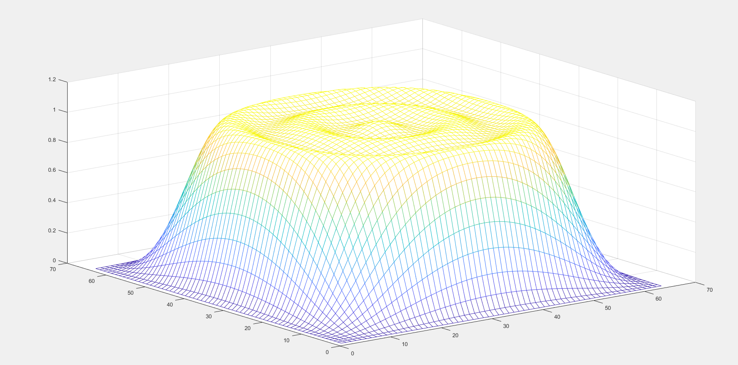
Fig. 3.2.1 Contour of Low Pass Filter using McClellan transform
The frequency response of the 2D FIR filter with CSD encoding with a word length of 12 and 5 SPT terms has not deviated from the magnitude response of the continuous coefficient’s magnitude response. Hence, the decreasing in word length bits and SPT terms can reduce the number of adders required for the implementation of filter architecture. Figure 3.2.3 to 3.2.8 represent the architectures of FIR filter for different row filters.
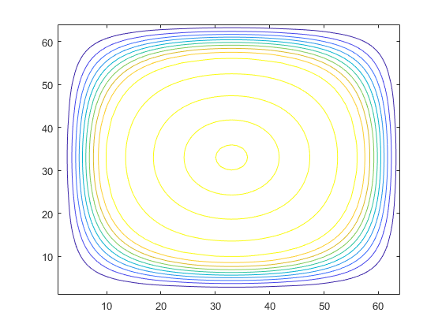
Fig 3.2.2 Frequency response of Low Pass Filter using McClellan transform

The FIR filter equations and architectures generated from the obtained filter coefficients following MATLAB simulation by giving the desired filter specifications are expressed from equation 3.2.1 to 3.2.6.
1.Row Filter 1 : Y = [x+(x-10)]>>12 + [(x-1)+(x-9)]>>12 +[(x-2)+(x-8)]>>9 - [(x-2)+(x-8)]>>11+[(x-3)+(x-7)]>>8 +[(x-4)+(x-6)]>>7 –[(x-4)+(x-6)]>>10 +[(x-4)+(x-6)]>>12 +[(x-5)]>>7 +[(x-5)]>>10 -[(x-5)]>>12 (3.2.1)

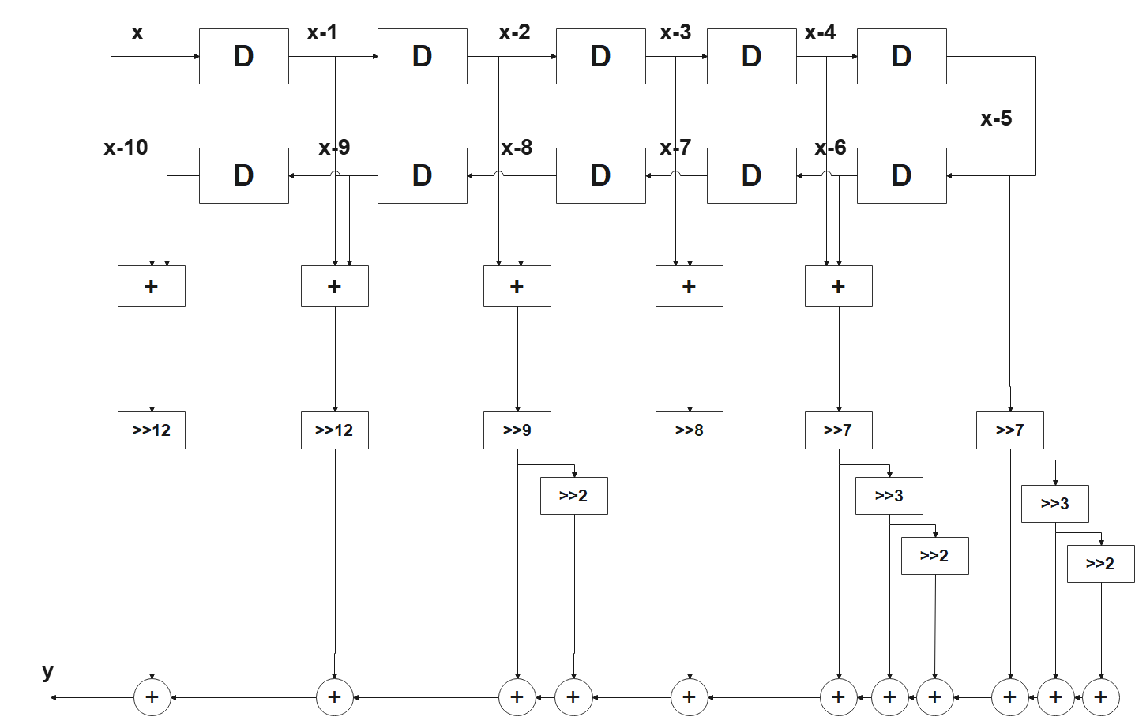

Fig. 3.2.3 Architecture of FIR filter in the direct form using CSD coefficients for row-filter 1
2.Row Filter 2 : Y = [x+(x-10)]>>12 +[(x-1)+(x-9)]>>9 - [(x-1)+(x-9)]>>12 +[(x-2)+(x-8)]>>8 - [(x-2)+(x-8)]>>10-[(x-2)+(x-8)]>>12 - [(x-3)+(x-7)]>>8 + [(x-3)+(x-7)]>>10 - [(x-3)+(x-7)]>>12 - [(x-4)+(x-6)]>>6 –[(x-4)+(x-6)]>>10 - [(x-4)+(x-6)]>>12 - [(x-5)]>>5 +[(x-5)]>>7 -[(x-5)]>>10 -[(x-5)]>>12 (3.2.2)
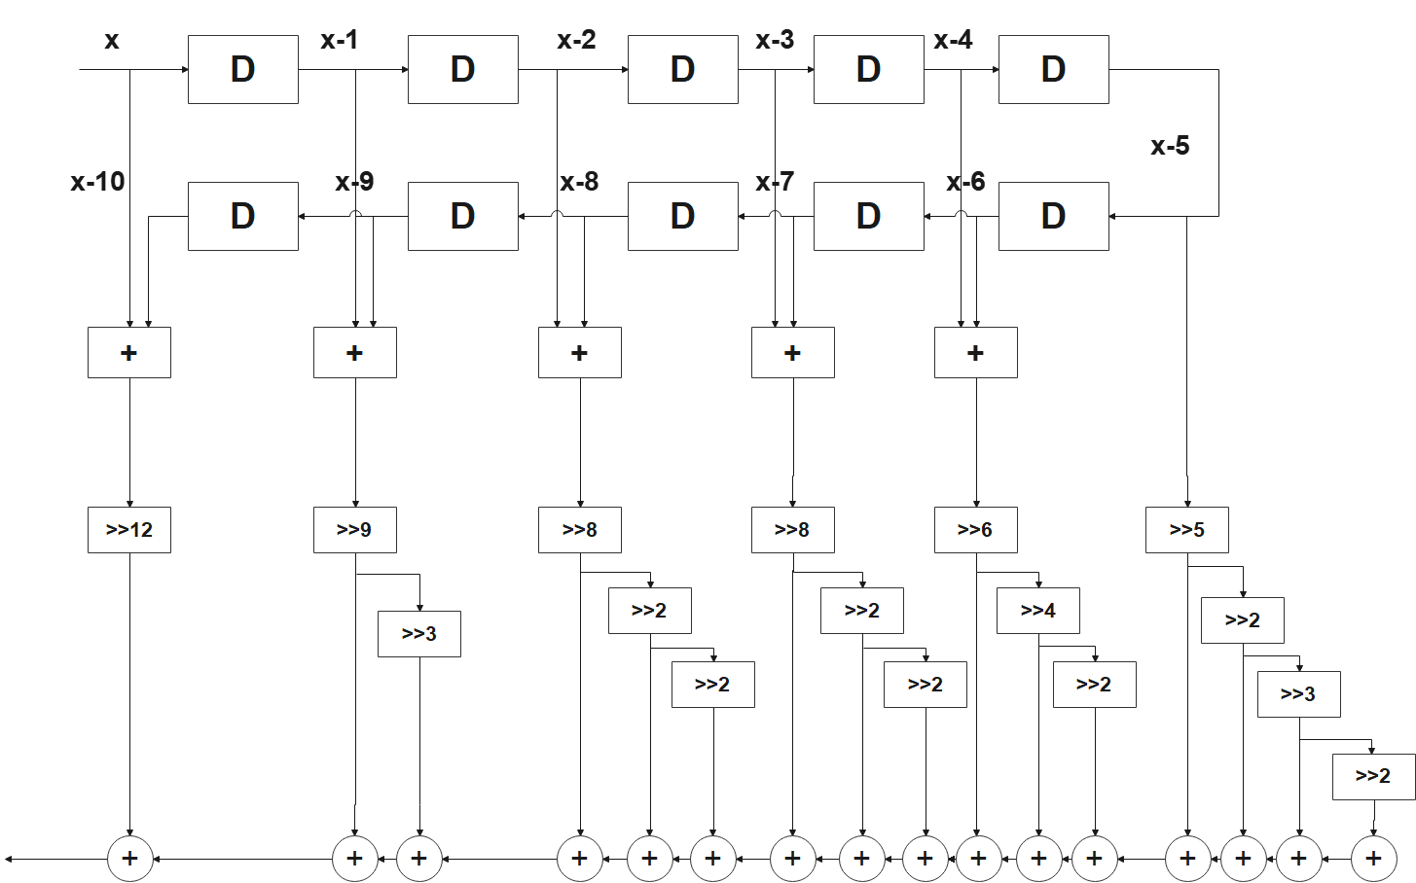
Fig.3.2.4 Architecture of FIR filter for row-filter 2
3.Row Filter 3 : Y = [x+(x-10)]>>9 - [x+(x-10)]>>11 +[(x-1)+(x-9)]>>8 - [(x-1)+(x-9)]>>10 - [(x-1)+(x-9)]>>12 -[(x-2)+(x-8)]>>8 - [(x-2)+(x-8)]>>10 + [(x-2)+(x-8)]>>12 - [(x-3)+(x-7)]>>7 + [(x-3)+(x-7)]>>9 + [(x-3)+(x-7)]>>12 + [(x-4)+(x-6)]>>5 –[(x-4)+(x-6)]>>7 + [(x-4)+(x-6)]>>10 + [(x-5)]>>4 - [(x-5)]>>6 + [(x-5)]>>9
(3.2.3)

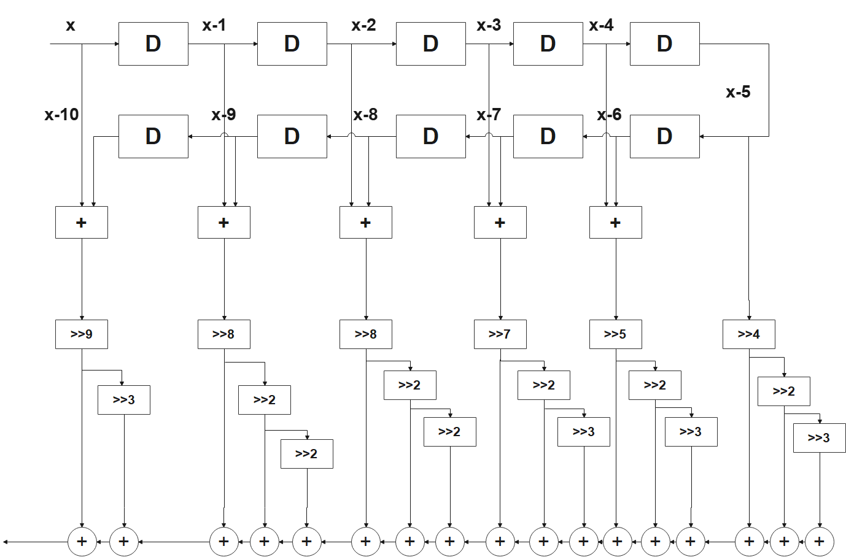

Fig.3.2.5 Architecture of FIR filter for row-filter 3

4.Row Filter 4 : Y = [x+(x-10)]>>8 - [(x-1)+(x-9)]>>8 + [(x-1)+(x-9)]>>10 - [(x-1)+(x-9)]>>12 -[(x-2)+(x-8)]>>7 + [(x-2)+(x-8)]>>9 + [(x-2)+(x-8)]>>12 + [(x-3)+(x-7)]>>6 + [(x-3)+(x-7)]>>8 - [(x-3)+(x-7)]>>12 - [(x-4)+(x-6)]>>5 –[(x-4)+(x-6)]>>8 + [(x-4)+(x-6)]>>11 - [(x-5)]>>3 + [(x-5)]>>5 + [(x-5)]>>8 + [(x-5)]>>10 - [(x-5)]>>12 (3.2.4)

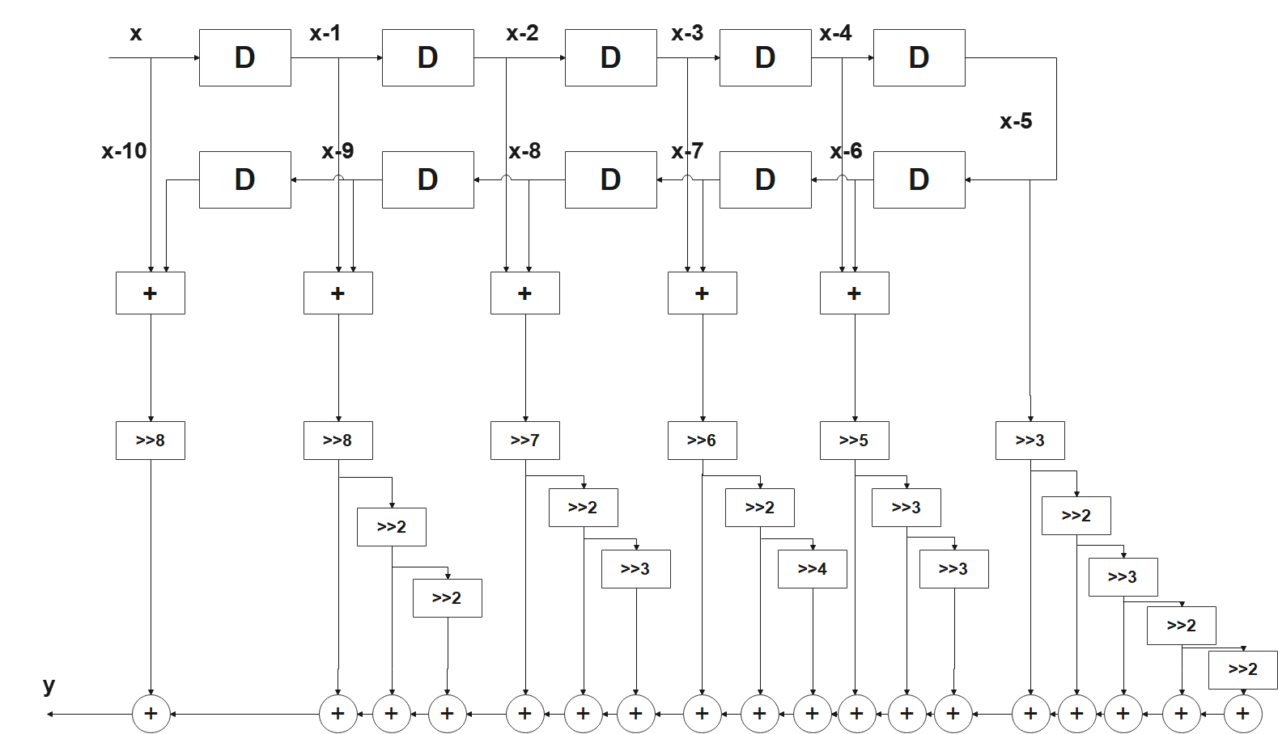

Fig.3.2.6 Architecture of FIR filter for row-filter 4
5.Row Filter 5 : Y = [x+(x-10)]>>7 - [x+(x-10)]>>10 + [x+(x-10)]>>12 - [(x-1)+(x-9)]>>6 - [(x-1)+(x-9)]>>10 - [(x-1)+(x-9)]>>12 + [(x-2)+(x-8)]>>5 - [(x-2)+(x-8)]>>7 + [(x-2)+(x-8)]>>10 - [(x-3)+(x-7)]>>5 + [(x-3)+(x-7)]>>8 + [(x-3)+(x-7)]>>11 + [(x-4)+(x-6)]>>9 + [(x-5)]>>3 + [(x-5)]>>5 - [(x-5)]>>10 (3.2.5)

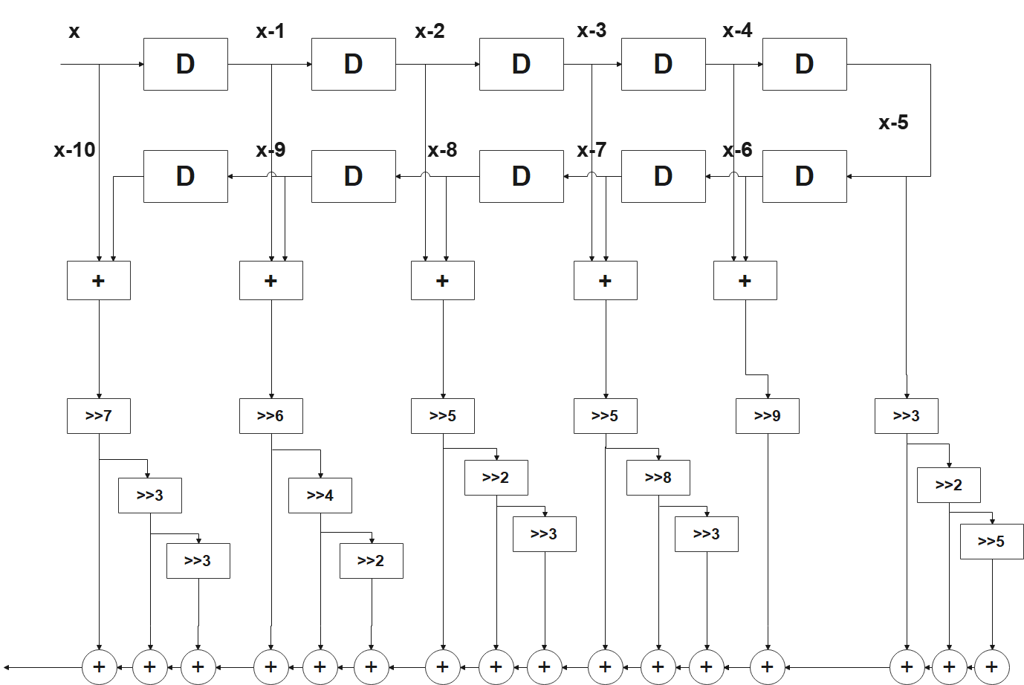
Fig.3.2.7 Architecture of FIR filter for row-filter 5
6.Row Filter 6 : Y = [x+(x-10)]>>7 - [x+(x-10)]>>10 - [x+(x-10)]>>12 - [(x-1)+(x-9)]>>5 + [(x-1)+(x-9)]>>7 - [(x-1)+(x-9)]>>10 - [(x-1)+(x-9)]>>12 + [(x-2)+(x-8)]>>4 - [(x-2)+(x-8)]>>6 + [(x-2)+(x-8)]>>9 - [(x-3)+(x-7)]>>3 + [(x-3)+(x-7)]>>5 + [(x-3)+(x-7)]>>8 + [(x-3)+(x-7)]>>10 - [(x-3)+(x-7)]>>12 + [(x-4)+(x-6)]>>3 + [(x-4)+(x-6)]>>5 - [(x-4)+(x-6)]>>10 + [(x-5)]>>1 + [(x-5)]>>3 + [(x-5)]>>5 + [(x-5)]>>8 - [(x-5)]>>10 (3.2.6)

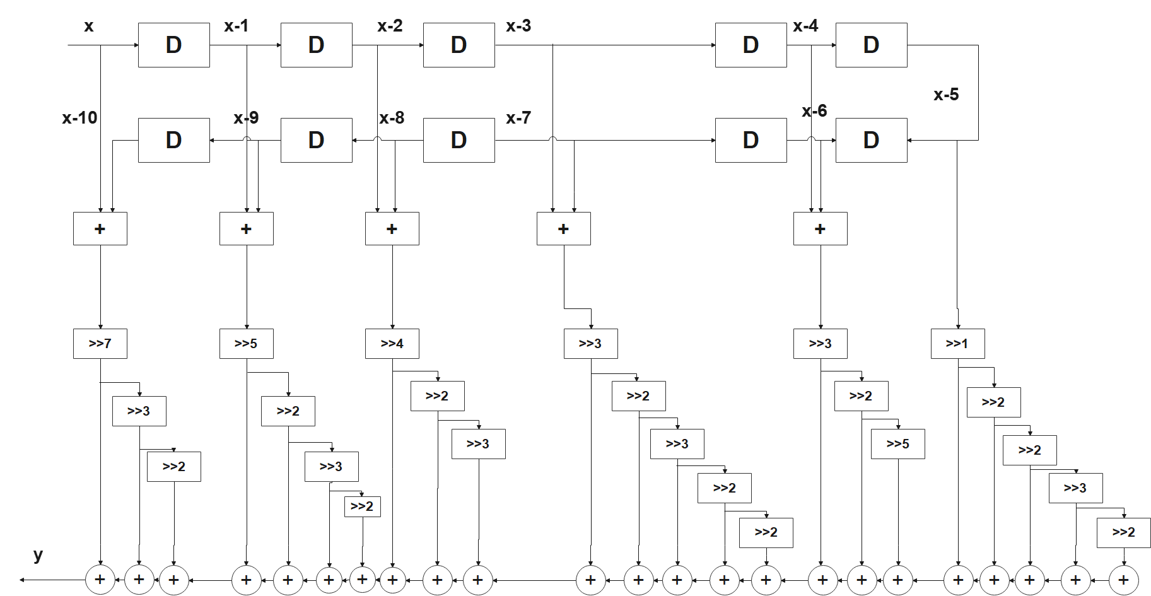

Fig.3.2.8 Architecture of FIR filter for row-filter 6

Chapter Four
Implementation of FIR Filter Architecture

In this section, the FIR filter architecture is implemented in hardware using continuous coefficients with MCM, multiplier less multiplication scheme using CSD. The filter coefficients obtained from the design of the circular symmetric FIR filter using MATLAB for the given specifications are considered for the hardware implementation. The multiple constant multiplications are different concerning the type of architectures.
The MCM operation is preferred for the transpose form type filter and Constant Array Vector Multiplication (CAVM) technique is used for the implementation of direct form filters. FIR filters can be implemented in 2 different types of architectures are (1) direct form, (2) Transpose form, structures. In this work, direct form structure is implemented. The general structure of direct form is shown in the Fig. 4.1, the structure of direct form with symmetry is shown in Fig 4.2, 2D FIR filter using CSD coefficients is shown in Fig 4.3 and the general architecture of FIR filter using shift register block is shown in Fig 4.4
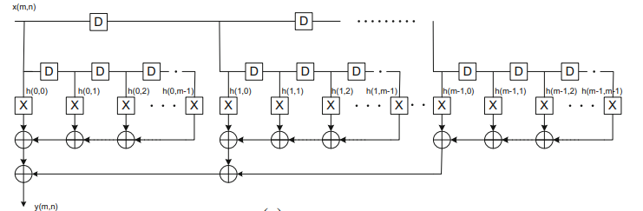
Fig 4.1 General Architectures of 2D FIR filters Fully Direct form
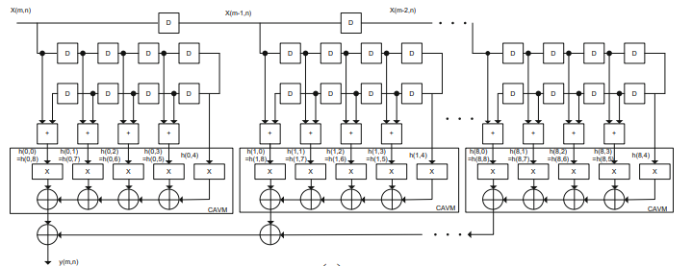
Fig. 4.2 Fully direct form 2D FIR Filter architecture for continuous coefficients with symmetry
4.1. Multiplier less FIR Filter Architecture implementation using CSD
In multiplier less filter operation, the filter coefficients are denoted by an optimized binary encoding number format for pruning the number of adders/subtractors. The constant-coefficient multiplication scheme is optimized using the CSD representation of coefficients of the filter. The number of adders is reduced to less than the non-zero bits of the coefficient. This representation is used to reduce the area and power consumption of the filter by encoding the coefficients in the fewest number of non-zero elements. This representation is most preferable for high-level synthesis. A coefficient or any number is considered as C=c_{w-1,} c_{w-2,}……c₁, c_{0.} Where each number $ci (P-1 ≥ I ≥ 0)$ is in the set of {-1, 0, 1} is a ternary number system. CSD representation is a special case and unique number representation, which consist of no two consecutive bits in the number are non-zero. It is possible minimum non-zero number representation is called canonic. The CSD number representation contains about 33% of fewer non zero bits comparatively conventional 2`s complement number [K.K. Parhi 1999]. The iterative algorithm represents the computation of CSD format for the p- bit number.
$$\dot{{\overline{c}}_{-1}=0}$$
$$α-1=0$$
$${\overline{c}}_{p}={\overline{c}}_{p-1}$$
$$for\left(i=0 top-1\right)$$
{$β_{i}={\overline{c}}_{i}⊕{\overline{c}}_{i-1}$// $denotes the XOR operation$
$α_{i}=\overline{α_{i-1}}β_{i}c_{i}=\left(1-2{\overline{c}}_{i+1}\right)α_{i}$}

The constant multiplication is generally carried out by adding or subtracting the number of partial products corresponding to the non-zero elements of the constant multiplier. The CSD representation of the coefficient consists of least number of non-zero bits and hence the number of subtractors and adders to compute the multiplication of input and coefficients are decreased.
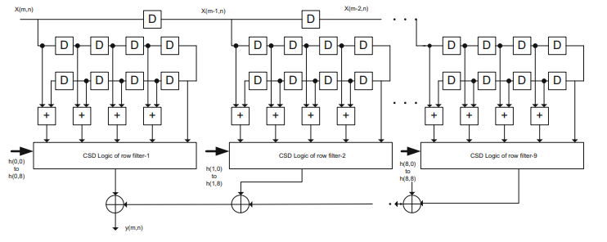
Fig 4.1.1 The architecture of 2D FIR filter in the fully direct form using CSD coefficients
A 12-bit CSD encoding process has been used for the FIR filter with circular symmetry and CSD coefficients are implemented in direct type FIR architecture are integrated as direct form FIR filter structure. The CSD format is used to represent the filter coefficients to avoid the multipliers and to reduce the number of adder/subtractors in the filter. Here, the multiplier is completely replaced with add and shift operations only. In this architecture, the row filter structure is implemented using adders, subtractors, and right shifters. According to CSD format, the shifting and adding operations are performed in the applied input signal.
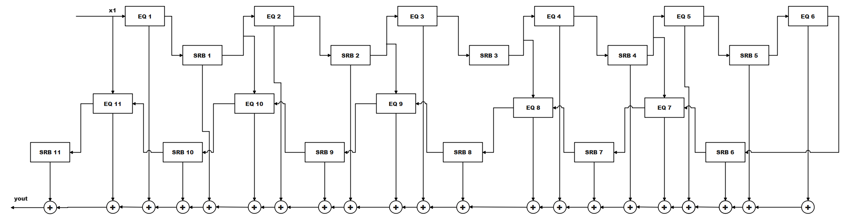
Fig. 4.1.2 Architecture of FIR filter using shift register blocks.

The RTL schematics of each row filter are represented as Fig 4.1.3 to 4.1.8
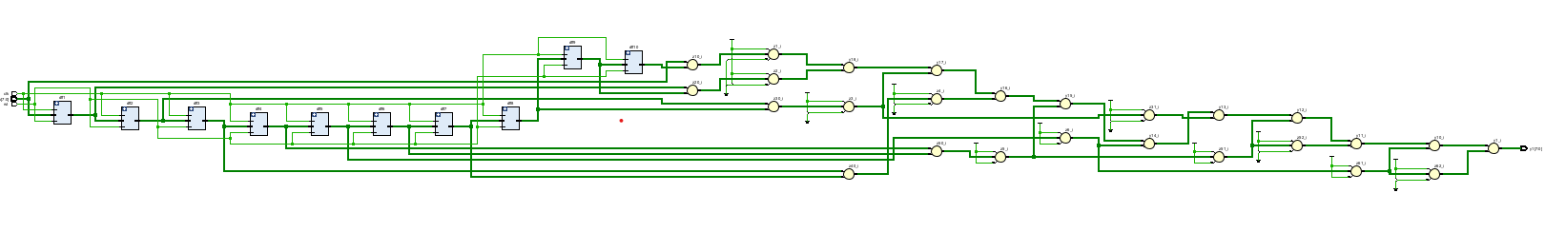Fig 4.1.3 RTL Schematic of row filter 1

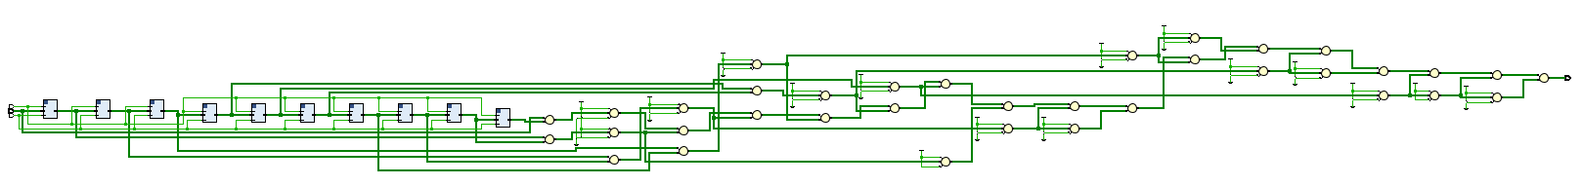

Fig 4.1.4 RTL Schematic of row filter 2

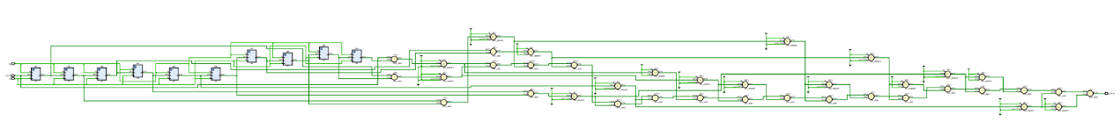

Fig 4.1.5 RTL Schematic of row filter 3

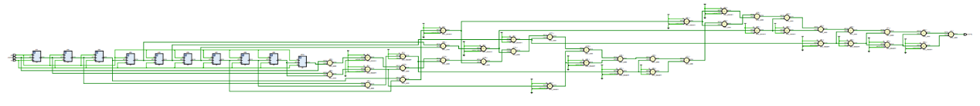

Fig 4.1.6 RTL Schematic of row filter 4

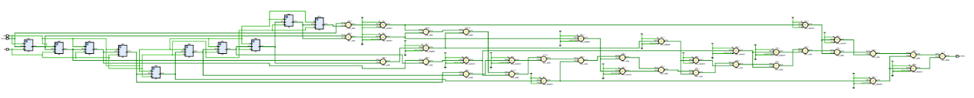

Fig 4.1.7 RTL Schematic of row filter 5

Fig 4.1.8 RTL Schematic of row filter 6

The RTL Schematic of the final two-dimensional (2D) FIR filter designed is represented as Fig 4.1.9 below.
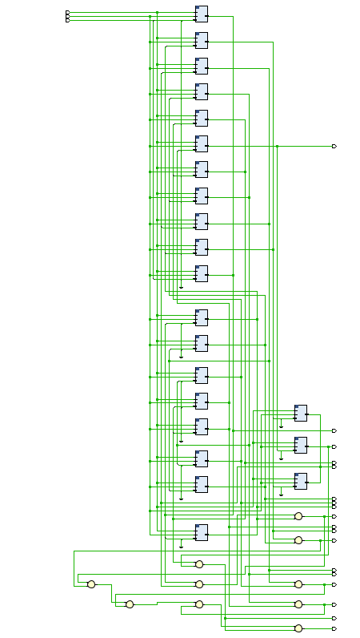

Fig 4.1.9 RTL Schematic of 2D FIR filter

Chapter Five
Performance Analysis and Results

5.1 Introduction
The circular symmetric FIR filter is designed using k^{th}-McClellan transform with T2 and P2 transformations in MATLAB. The direct form architecture are implemented using generic multipliers for the continuous coefficients with CAVM in Hardware Description Language (HDL). The continuous coefficients are converted into CSD number format to implement multiplier less architectures. The optimization is introduced in CSD reduce the complexity in hardware.
The reconfigurable designs are implemented using Xilinx Vivado tool with Verilog HDL. The direct type of filter architectures is proposed to meet the desired specifications in multiplier less multiplication technique.
For reconfigurable applications, Zynq-7 FPGA is considered as target device and the architecture of FIR filters are implemented. The continuous coefficients design requires DSP48 slices for the computation of the multiplier. For the multiplier less design, no DSP48 slices were used, and these resources may be used for the other computations in the application. Next, the CSD decreases the number of adders/subtractors and registers also. The power dissipation and delay of both architectures is directly decreased. The different input bit widths are considered for the filter with multipliers and multiplier less filter architectures. The input bit width is reduced from 16-bits to 8-bits for the continuous coefficient 2D filter, then the output bit width also reduced. This can prune the complexity of the filter in terms of area, power, and delay. This is because the input bit width affects the size of the adder/subtractors, multipliers, and registers.

Table:
Filter Coefficients | CSD(WL=12) | CSD (WL=14)
0.00034127651834 | .00000000000+ | .00000000000+0+
0.000341276518339 | .00000000000+ | .00000000000+0+
0.001535744332523 | .00000000+0-0 | .00000000+0-00+
0.004095318220062 | .0000000+0000 | .0000000+000+0-
0.007166806885109 | .000000+00-0+ | .000000+00-0+0+
0.008600168262131 | .000000+00+0- | .000000+00+0-00
0.000341276518339 | .00000000000+ | .00000000000+0+
0.001831757040376 | .00000000+00- | .00000000+000-0
0.002709378181158 | .0000000+0-0- | .0000000+0-0-00
-0.003315045803642 | .0000000-0+0- | .0000000-00+0+0
-0.016868387157439 | .00000-000-0- | .00000-000-0-00
-0.024668887389353 | .0000-0+00-0- | .0000-0+00-0-00
0.001535744332523 | .00000000+0-0 | .00000000+0-00+
0.002709378181158 | .0000000+0-0- | .0000000+0-0-00
-0.004713702487703 | .0000000-0-0+ | .0000000-0-0+0-
-0.005682561923213 | .000000-0+00+ | .000000-0+00+0-
0.024649517281923 | .0000+0-00+00 | .0000+0-00+0+0-
0.048889485737597 | .000+0-00+000 | .000+0-00+0000+
0.004095318220062 | .0000000+0000 | .0000000+000+0-
-0.003315045803642 | .0000000-0+0- | .0000000-00+0+0
-0.005682561923213 | .000000-0+00+ | .000000-0+00+0-
0.019300146101299 | .00000+0+000- | .00000+0+000-00
-0.027080046645711 | .0000-00+00+0 | .0000-00+000+0+
-0.089304781293037 | .00-0+00+0+0- | .00-0+00+00+00+
0.007166806885109 | .000000+00-0+ | .000000+00-0+0+
-0.016868387157439 | .00000-000-0- | .00000-000-0-00
0.024649517281923 | .0000+0-00+00 | .0000+0-00+0+0-
-0.027080046645711 | .0000-00+00+0 | .0000-00+000+0+
0.001990013552999 | .00000000+000 | .00000000+00000
0.155509543046362 | .00+0+0000-00 | .00+0+0000-0+0-
0.008600168262131 | .000000+00+0- | .000000+00+0-00
-0.024668887389353 | .0000-0+00-0- | .0000-0+00-0-00
0.048889485737597 | .000+0-00+000 | .000+0-00+0000+
-0.089304781293037 | .00-0+00+0+0- | .00-0+00+00+00+
0.155509543046362 | .00+0+0000-00 | .00+0+0000-0+0-
0.659225298223813 | .+0+0+00+0-00 | .+0+0+00+0-0000
0.007166806885109 | .000000+00-0+ | .000000+00-0+0+
-0.016868387157439 | .00000-000-0- | .00000-000-0-00
0.024649517281923 | .0000+0-00+00 | .0000+0-00+0+0-
-0.027080046645711 | .0000-00+00+0 | .0000-00+000+0+
0.001990013552999 | .00000000+000 | .00000000+00000
0.155509543046362 | .00+0+0000-00 | .00+0+0000-0+0-
0.004095318220062 | .0000000+0000 | .0000000+000+0-
-0.003315045803642 | .0000000-0+0- | .0000000-00+0+0
-0.005682561923213 | .000000-0+00+ | .000000-0+00+0-
0.019300146101299 | .00000+0+000- | .00000+0+000-00
-0.027080046645711 | .0000-00+00+0 | .0000-00+000+0+
-0.089304781293037 | .00-0+00+0+0- | .00-0+00+00+00+
0.001535744332523 | .00000000+0-0 | .00000000+0-00+
0.002709378181158 | .0000000+0-0- | .0000000+0-0-00
-0.004713702487703 | .0000000-0-0+ | .0000000-0-0+0-
-0.005682561923213 | .000000-0+00+ | .000000-0+00+0-
0.024649517281923 | 0000+0-00+00 | .0000+0-00+0+0-
0.048889485737597 | .000+0-00+000 | .000+0-00+0000+
0.000341276518339 | .00000000000+ | .00000000000+0+
0.001831757040376 | .00000000+00- | .00000000+000-0
0.002709378181158 | .0000000+0-0- | .0000000+0-0-00
-0.003315045803642 | .0000000-0+0- | .0000000-00+0+0
-0.016868387157439 | .00000-000-0- | .00000-000-0-00
-0.024668887389353 | .0000-0+00-0- | .0000-0+00-0-00
0.000034127651834 | .00000000000+ | .00000000000+0+
0.000341276518339 | .00000000000+ | .00000000000+0+
0.001535744332523 | .00000000+0-0 | .00000000+0-00+
0.004095318220062 | .0000000+0000 | .0000000+000+0-
0.007166806885109 | .000000+00-0+ | .000000+00-0+0+
0.008600168262131 | .000000+00+0- | .000000+00+0-00

5.2 Sample Outputs
The utilization summary outputs of each row filter are obtained and represented below
- Row Filter 1
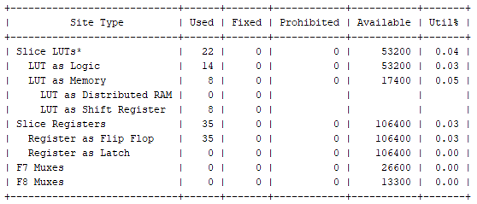
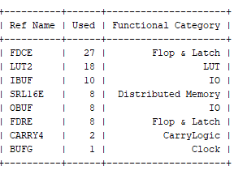

- Row Filter 2
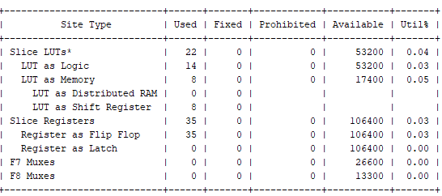
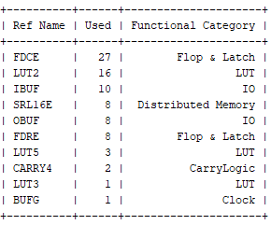
- Row filter 3
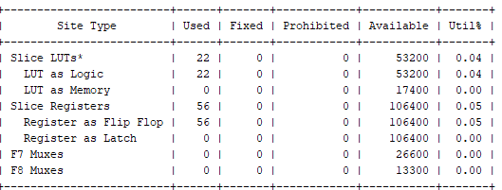
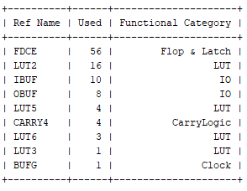
- Row Filter 4
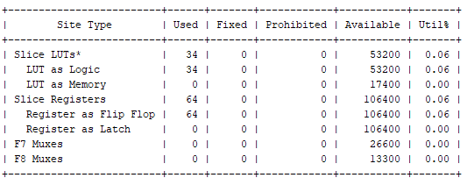
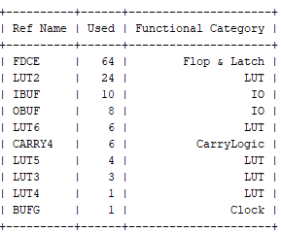

- Row Filter 5
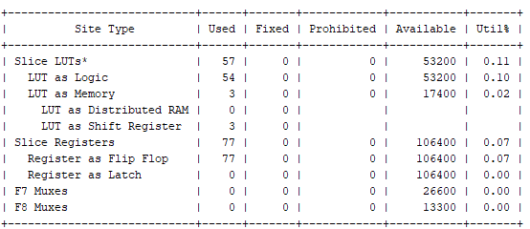
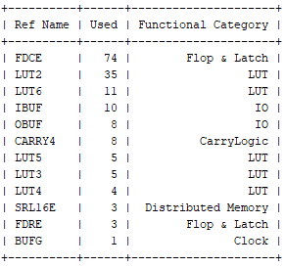
- Row Filter 6
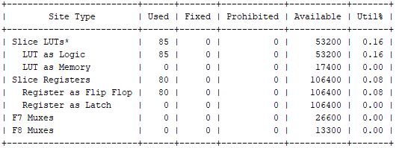
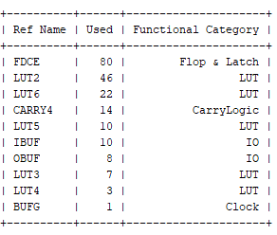
- Shift Register Block
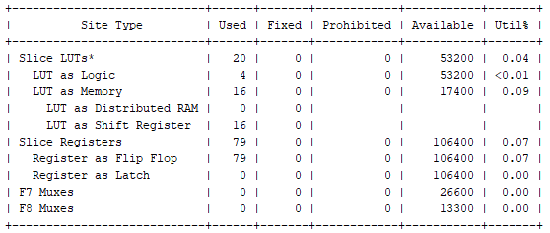
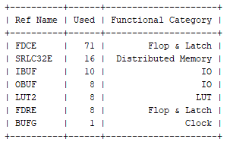

- Final FIR Filter Output
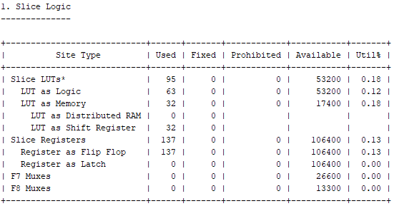
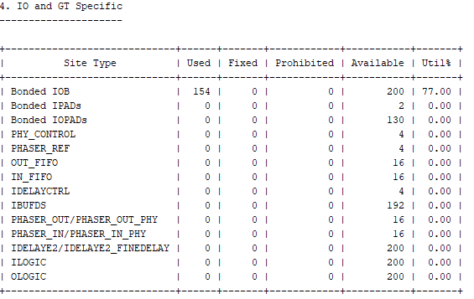
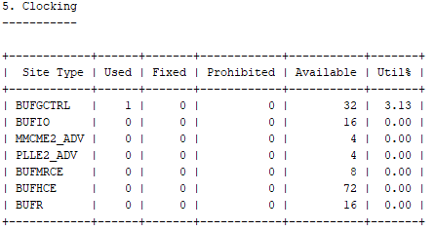

ASIC Synthesis Results:
The circular symmetry-based 2-D FIR filter is designed for the given specification using modified K^{th}-McClellan transformations such as with T1 & T2 transformations and P2 transformations in MATLAB software, and the corresponding coefficients are generated. The Fully-Direct type architecture is implemented using conventional multipliers for the continuous coefficients with CAVM and MCM techniques, respectively. The continuous coefficients are represented by the CSD format to implement multiplierless 2-D FIR filter architectures.
All these architectures are coded by Verilog HDL and simulated by Incisive Enterprise Simulator-XL-15.2 tool from Cadence. The semi-custom ASIC design-based architectures for 2-D FIR filters are implemented in TSMC 45nm CMOS generic library using RTL encounter from Cadence tools. The synthesis tools generate the power, delay, and area reports.
The multiplierless design-based filter Fully-Direct type 2-D FIR filter architecture lead to reducing the area and power to the continuous coefficient 2-D FIR filter. The size of the registers of Fully-Direct filter will not change after multiplication process because all registers are placed input side only. The implementation of each row filter of Fully-Direct type filter needs minimum adders than the transposed form. The delay of the continuous coefficient implementation with generic multipliers is less than the shift-add designs due to more operations being required and connected in series in the multiplierless design. To reduce this delay to some extent the Carry Save Adders (CSA) are used for filter structural adders.

Figure 4.14: The power comparison for different coefficients-based filter architectures.

The area, delay, and power values generated by the ASIC-based tools are compared in Table 4.9. The table presents the two different coefficient types and two types of 2-D FIR filter architectures with two different input bit widths compared in terms of area, power, and delay.
The line graph comparison of power and area of conventional continuous coefficients, CSD, concerning the different number of bits is shown in Figure 4.14 and Figure 4.15. It can be observed that the CSD architecture's power and area are very much less when compared with continuous coefficients-based architectures.

Figure 4.15: The area occupancy of different coefficients-based 2-D FIR filters.

The performance metrics of proposed circular symmetric-based 2-D FIR filter architectures in Fully-Direct form is compared with the existing state-of-the art works in Table 4.10. The ADP and PDP values are evaluated for all the architectures and compared. Total 75% and 85% of power-saving are obtained by proposed filter architectures when compared with 2-D FIR filter architecture proposed in Kumar et al. [45] and Mohanty et al. [47], respectively. The power-saving obtained is 45% by the proposed-1 2-D FIR filter than Khoo et al. [31] and Chen et al. [53] for fixed coefficients. This power-saving is achieved by replacing the power-hunger multiplier blocks with the shift-add operations using CSD representation of coefficients in 2-D filters.
Table 4.9: Comparison of custom design-based VLSI design metrics of 2-D FIR filter in different architectures.
Type of coefficients | architecture | 8-bit filter input |  |  | 16-bit filter input
 |  | Area  (µm²) | Power  (mW) | Delay  (ns) | Area  (µm²) | Power  (mW) | Delay  (ns)
Continuous Coefficients | Fully-Direct | 89010 | 34.8 | 9.05 | 189543 | 51.002 | 18.00
CSD | Fully-Direct | 3109 | 2.1803 | 6.28 | 16239 | 5.1358 | 16.56

Table : Synthesis results comparison of the proposed 2-D FIR filter architectures with state-of-the art works.
Architectures | N | Area  (µm²) | Power  (mW) | Delay  (ns) | ADP  (µm^{2 .}ms) | PDP  (µm^{2 .} mW)
Kumar et al. [42] | 8 | 651615 | 20.1069 | 6.53 | 0.531880 | 131.3
Mohanty et al. [43] | 8 | 1720962 | 50.0106 | 11.79 | 25.37555 | 589.62
Khoo et al. [31] | 8 | 356293 | 9.3807 | 13.1 | 4.636084 | 122.89
Chen et al. [44] | 9 | 22359 | 9.356 | 19.23 | 0.429963 | 179.91
Proposed 1  (Fully-Direct) | 11 | 16239 | 5.1358 | 16.56 | 0.284127 | 84.58

The vast reduction in area is achieved by proposed filters when compared with architectures proposed by Kumar et al. [45], Mohanty et al. [47], and Khoo et al. [31]. The 47% and 39% of ADP, and 36% and 53% of PDP values proposed works are reduced when compared with ADP and PDP results of Kumar et al. [45] and Chen et al. [53], respectively. The proposed architecture’s ADP and PDP values are reduced significantly than Mohanty et al. [47] and Khoo et al. [31]. The ADP and PDP of the proposed works are outperformed the existing filter architectures.

Conclusion

In this paper, the prominent architectures are designed and implemented using multiplierless constant multiplications and described in fully direct form architectures of 2D FIR filter. The filter coefficients are generated for the desired specifications to achieve circular symmetry using k^{th}-Park's McClellan transformation, T2 and P2 transformation techniques. The continuous coefficients are optimized using a CSD number format to reduce the number of adder/subtractors.
A low complexity circular symmetric 2D FIR filter is proposed, which has been designed in MATLAB and implemented in TSMC 45nm CMOS technology using the generic library. High-level synthesis is carried out for the continuous filter with generic multipliers and multiplier less designs with CSD.
For area-efficient applications, the fully direct form is the best architecture to implement symmetric 2D FIR filters in custom designs and FPGA designs. For high-speed applications, the hybrid-II form is the best architecture on Custom designs and reconfigurable design platform. For low power applications, the algorithms to optimize hardware complexity is better to implement the filter in a fully direct form in ASIC platform. The experimental results indicate that high-level synthesis algorithms have a significant impact on the multiplier less design of 2D FIR filters in terms of complexity, power, and performance using both architectures. The limitation of the filter design is fixed coefficients are considered for certain specifications only.

References

- [1] R. Mersereau, W. Mecklenbrauker, and T. Quatieri, "McClellan transformations for two-dimensional digital filtering-Part I: Design." IEEE Transactions on Circuits and Systems, Vol. 23, no.7, pp. 405-414, 1976.
- T. Barbu, “Gabor filter-based face recognition technique” Proc. Rmanian Acad. Ser. A Vol. 11, no. 3, pp. 277–283, 2010.
- A.K. Jain, Fundamentals of Digital Image Processing, Prentice-Hall, Englewood Cliffs, 1989.
- M.A. Sid-Ahmed, Image Processing: Theory, Algorithms and Architectures McGraw-Hill, New York, 1995.
- R. M. Joshi, A. Madanayake, J. Adikari, and L. T. Bruton, “Synthesis and array processor realization of a 2-D IIR beam filter for wireless applications” IEEE Transactions on Very Large-Scale Integration (VLSI) Systems, Vol. 20, no. 12), pp. 2241–2254, 2012.
- F. J. Kurdahi, and A. C. Parker, “Techniques for area estimation of VLSI layouts,” in IEEE Transactions on Computer-Aided Design of Integrated Circuits and Systems, Vol. 8, no. 1, pp. 81-92, 1989.
- M. Pedram, & S. Nazarian, “Thermal modeling, analysis, and management in VLSI circuits: Principles and methods” Proceedings of the IEEE, Vol. 94, no. (8), pp. 1487-1501, 2006.
- V. G. Oklobdzija, B. R. Zeydel, H. Dao, S. Mathew, and R. Krishnamurthy, “Energy-delay estimation technique for high-performance microprocessor VLSI adders” Proceedings 2003 16th IEEE Symposium on Computer Arithmetic, pp. 272-279, 2003.
- T. Bindima, and Elizabeth Elias, “Design of efficient circularly symmetric two-dimensional variable digital FIR filters” Journal of advanced research, Vol. 7, no. 3, pp. 336-347, 2016.
- T. Bindima, Manju Manuel, and Elizabeth Elias, “An efficient transformation for two dimensional circularly symmetric wideband FIR filters” 2016 IEEE Region 10 Conference (TENCON). IEEE, pp. 2838-2841, 2016.
- M. Manuel, R. Krishnan, and E. Elias, “Design of circularly symmetric 2D sharp wideband filters using FRM and multiplierless transformation” International Journal of Signal and Imaging Systems Engineering, Vol. 8, no. 3, pp. 177-186, 2015.
- K. S. Yeung, and S.C. Chan “Design and implementation of multiplierless tunable 2D FIR filters using McClellan transformation” IEEE international symposium on circuits and systems (ISCAS 2002), Vol. 5, pp. 761–764, 2002.
- J. C. Liu, and Y. L. Tai, “Design of 2-D wideband circularly symmetric FIR filters by multiplierless high-order transformation” IEEE Transactions on Circuits and Systems I: Regular Papers, Vol. 58, no. 4, pp. 746-754, 2010.
- J. J Shyu, S. C. Pei, and Y. D. Huang,” Design of variable two-dimensional FIR digital filters by McClellan transformation” IEEE Transactions on Circuits and Systems I: Regular Papers, Vol. 56, no. 3, pp. 574-582, 2008.
- O. Venkata Krishna, C. Venkata Narasimhulu, and K. Satya Prasad, “Design and implementation of low complexity circularly symmetric 2D FIR filter architectures” Multidimensional Systems and Signal Processing, Vol. 31, no. 4, pp. 1385-1410, 2020.
- A. Chandra, and S. Chattopadhyay, “A new strategy of image denoising using multiplier-less FIR filter designed with the aid of differential evolution algorithm” Multimedia Tools and Applications, Vol. 75, no. 2, pp. 1079-1098, 2016.
- S. Kockanat, and N. Karaboga, “The design approaches of two-dimensional digital filters based on metaheuristic optimization algorithms: a review of the literature” Artificial Intelligence Review, Vol. 44, no. 2, pp. 265-287, 2015.
- A. K. Dwivedi, K. S. Ghosh, and N. D. Londhe, “Low power 2D finite impulse response filter design using modified artificial bee colony algorithm with experimental validation using field-programmable gate array” IET Science, Measurement & Technology, Vol. 10, no. 6, pp. 671-678, 2016.
- A. Aggarwal, M. Kumar, T. K. Rawat, and D. K Upadhyay, “Optimal design of 2D FIR filters with quadrantally symmetric properties using fractional derivative constraints” Circuits, Systems, and Signal Processing, Vol. 35, no. 6, pp. 2213-2257, 2016.
- T. J. Su, C. H. Kuo, W. P. Tsai, and C. C. Hou, “A hybrid of clonal selection algorithm and frequency sampling method for designing a 2-D FIR filter” 4th IEEE international symposium on electronic design, test and applications, IEEE, pp. 274-278, 2008.
- T. B. Deng, “Design of linear-phase variable 2-D digital filters using matrix-array decomposition” IEEE Transactions on Circuits and Systems II: Analog and Digital Signal Processing, Vol. 50, no. 6, pp. 267-277, 2003.
- T. Williams, M. Ahmadi, and W.C. Miller, “Design of 2D FIR and IIR digital filters with canonical signed digit coefficients using singular value decomposition and genetic algorithms. Circuits, Systems & Signal Processing, Vol. 26, no. 1, pp. 69–89, 2007.
- T. B. Deng, “Design of arbitrary-phase variable digital filters using SVD-based vector-array decomposition” IEEE Transactions on Circuits and Systems I: Regular Papers, Vol. 52, no. 1, pp. 148-167, 2005.
- T. B. Deng, “Design of arbitrarily variable 2-D digital filters using array–array decomposition” Signal Processing, Vol. 66, no. 1, pp. 95-110, 1998.
- C. K. Pun, S. C. Chan, and K. L. Ho, “Efficient 1D and circular symmetric 2D FIR filters with variable cutoff frequencies using the Farrow structure and multiplier-block” ISCAS 2001. The 2001 IEEE International Symposium on Circuits and Systems Vol. 2, pp. 561-564, 2001.
- T. Bindima, and Elizabeth Elias, “Design and Implementation of Low Complexity 2-D Variable Digital FIR Filters Using Single-Parameter-Tunable 2-D Farrow Structure” IEEE Transactions on Circuits and Systems I: Regular Papers, Vol. 65, no. 2, pp. 618-627, 2017.
- T. Bindima, and Elizabeth Elias, “Low-Complexity 2-D Digital FIR Filters Using Polyphase Decomposition and Farrow Structure” IEEE Transactions on Circuits and Systems I: Regular Papers, Vol. 66, no. 6, pp. 2298-2308, 2019.
- L. D. Van, “A new 2-D systolic digital filter architecture without global broadcast” IEEE transactions on very large-scale integration (VLSI) systems, Vol. 10, no. 4, pp. 477-486, 2002.
- B. K. Mohanty, S. Al-Maadeed, and A. Amira, “Systolic architecture for hardware implementation of two-dimensional non-separable filter-bank” 2013 8th IEEE Design and Test Symposium, IEEE, pp. 1-6, 2013.
- B. K. Mohanty, and P. K. Meher, “High throughput and low-latency implementation of a bit-level systolic architecture for 1D and 2D digital filters.” IEE Proceedings-Computers and Digital Techniques, Vol. 146, no. 2, pp. 91-99, 1999.
- I. H. Khoo, H. C. Reddy, L. D. Van, and C. T. Lin, “Generalized formulation of 2-D filter structures without global broadcast for VLSI implementation” 2010 53rd IEEE international Midwest symposium on circuits and systems, IEEE, pp. 426-429, 2010.
- G. D. Licciardo, C. Cappetta, L. D. Benedetto, A. Rubino, and R. Liguori, “Multiplier-less stream processor for 2D filtering in visual search applications” IEEE Transactions on Circuits and Systems for Video Technology, Vol. 28, no. 1, pp. 267-272, 2016.
- A. Yurdakul, “Multiplierless implementation of 2-D FIR filters” Integration, Vol. 38, no. 4, pp. 597-613, 2005.
- L. Aksoy, P. Flores, and J. Monteiro, “A tutorial on multiplierless design of FIR filters: algorithms and architectures” Circuits, Systems, and Signal Processing, Vol. 33, no. 6, pp. 1689-1719, 2014.
- P. C. Shrivastava, P. Kumar, M. Tiwari, and A. Dhawan, “Efficient Architecture for the Realization of 2-D Adaptive FIR Filter Using Distributed Arithmetic” Circuits, Systems, and Signal Processing, Vol. 40, no. 3, pp. 1458-1478, 2021.
- C. S. Vinitha, and R. K. Sharma, “New approach to low-area, low-latency memory-based systolic architecture for FIR filters” Journal of Information and Optimization Sciences, Vol. 40, no. 2, pp. 247-262, 2019.
- P. Y. Chen, L. D. Van, H. C. Reddy, and C. T. Lin, “A new VLSI 2-D diagonal-symmetry filter architecture design” APCCAS 2008-2008 IEEE Asia Pacific Conference on Circuits and Systems, IEEE, pp. 320-323, 2008.
- P. Y. Chen, L. D. Van, H. C. Reddy, and C. T. Lin, “A new VLSI 2-D fourfold-rotational-symmetry filter architecture design” 2009 IEEE International Symposium on Circuits and Systems (ISCAS), IEEE, pp. 93-96, 2009.
- P. Y. Chen, L. D. Van, H. C. Reddy, and I. H. Khoo, “Area-efficient 2-D digital filter architectures possessing diagonal and four-fold rotational symmetries” 2013 9th International Conference on Information, Communications & Signal Processing, IEEE, pp. 1-5, 2013.
- I. H. Khoo, H. C. Reddy, L. D. Van, and C. T. Lin, “General formulation of shift and delta operator based 2-D VLSI filter structures without global broadcast and incorporation of the symmetry” Multidimensional Systems and Signal Processing, Vol. 25, no. 4, pp. 795-828, 2014.
- P. Kumar, P. C. Shrivastava, M. Tiwari, and A. Dhawan, “Realization of Efficient Architectures for Digital Filters: A Survey” Advances in VLSI, Communication, and Signal Processing. Springer, Singapore, pp. 861-882, 2020.
- P. Kumar, P. C. Shrivastava, M. Tiwari, and G. R. Mishra, “High-throughput, area-efficient architecture of 2-D block FIR filter using distributed arithmetic algorithm” Circuits, systems, and signal processing, Vol. 38, no. 3, pp. 1099-1113, 2019.
- B. K. Mohanty, P.K. Meher, and A. Amira, “Memory Footprint Reduction for Power-Efficient Realization of 2-D Finite Impulse Response Filters” IEEE Trans Circuits Syst. I, Vol. 61, no. 1, pp. 120-133, 2014.
- P. Y. Chen, L. D. Van, I. H. Khoo, H. C. Reddy, and C. T. Lin, “Power-efficient and cost-effective 2-D symmetry filter architectures” IEEE Transactions on Circuits and Systems I: Regular Papers, Vol. 58, no. 1, pp. 112-125, 2010.

